Notes

Kim and Andy Suberman from ReactiveOps

* Kubernetes Expert

What are we building?

Spinning up 3 kubernetes cluster

* Gke-spinnaker – spinnaker 1.8
* Gke-central – istio-system
* Gke-west – istio-system

Container Registry uses skaffold to make small changes to the front-end located in gke-central

Distributed applications in the cloud

Multi-cloud

* Use the right provider who are good at it

Create a culture and tooling

* Midpoint of heterogeneous and homogeneous

Cluster management

Application management

Service discovery

Federation vs Cluster Independence

High-level overview of Kubernetes

* Declarative way to describe your applications
* “You declare your desired state on services”

Cluster

* Has a master node and multiple worker nodes

Master node

* Always running 3 processes
  + Kubernetes API – brains of the system
  + Scheduler
  + Controller managers

In a node

* Kubeproxy – handles complex proxy inter routing
* Kubelet
* Container runtime – using docker or rocket

**Everything in Kubernetes is a Resource**

**Resources are endpoints in Kubernetes API**

**Labels to keep track of Resources**

**Pod Deployment Service Ingress Secret Configmap**

Configmap – binds to the pod

Secret – objects designed to hold password, tokens, OAuth

**Custom Resources**

* RBAC manager
* Istio

Command: kubectx

Shows you what context you are currently using (what cluster)

**Spinnaker**

* Can let you view all the clusters
* Netflix support this open-source, then also Google
* Application management
* Configuration management

Safe Deployment with Canary

* Manual Judgements
* Execution Windows
* Manual Rollbacks
* Automated Rollbacks with Kayenta (automated Canary deployment)

From the lab:

Username:

googlece33172\_student@qwiklabs.net

Password:

g4x7n8vQ4t

GCP Project ID:

qwiklabs-gcp-59d68077bb887385



Kubernetes is quickly becoming the platform of choice for many enterprise developers and devops. As environments grow, a single Kubernetes cluster is no longer an option. Deploying and running applications in multiple Kubernetes clusters comes with added complexity. Thanks to the open source community, we have numerous tools to help us manage multiple clusters and application deployment across these clusters. This lab focuses on best practices around operating multiple clusters, managing application deployments across multiple clusters, and advanced routing scenarios in a multi-cluster Kubernetes environment.

What You'll Learn

In this workshop you will learn how:

* **Build**
* Developers use tools such as [Skaffold](https://github.com/GoogleContainerTools/skaffold" \t "_blank) for local development and testing prior to deploying it in staging/production environment.
* Once local development is completed, developers can use [Cloud Build](https://cloud.google.com/cloud-build/) to store the image in a container repository such as [Google Container Registry](https://cloud.google.com/container-registry/) (GCR.io).
* **Deploy**
* Deploy applications to multiple Kubernetes clusters using [Spinnaker](https://www.spinnaker.io/) (an open source continuous delivery tool).
* Trigger Continuous Delivery pipelines using Spinnaker to deploy an application across multiple clusters to staging, canary and production phases.
* **Control**
* Use NGINX to globally load balance traffic to multiple Kubernetes clusters
* Use [Istio](https://istio.io/" \t "_blank) advanced routing to manipulate traffic to production and canary versions of the application within each cluster
* Secure microservices traffic using mTLS
* Control traffic using policy/quota management and enforcement with Istio.
* **Monitor**
* Monitor traffic using open source tools such as:
* Metric and visualization with [Prometheus](https://prometheus.io/) and [Grafana](https://grafana.com/)
* Distributed tracing with [Jaeger](https://www.jaegertracing.io/)
* Microservices visualization with [ServiceGraph](https://github.com/istio/istio/tree/master/addons/servicegraph" \t "_blank)
* Logging and troubleshooting with [Google Stackdriver](https://cloud.google.com/stackdriver/) (GCP Monitoring and management for services, containers, applications, and infrastructure)

For this workshop, you utilize 3 Kubernetes Engine clusters.

* gke-central and gke-west are deployed in us-central1 and us-west1regions respectively, and are used for running a simple two tier web application written in Go.
* gke-spinnaker is used for continuous delivery/deployment of the web app using Spinnaker to gke-central and gke-west. This cluster is also used for globally load balancing application traffic to gke-central and gke-west using an NGINX load balancer.
* gke-central and gke-west also have Istio Service Mesh installed. You use Istio's advanced traffic management features to manipulate traffic to different versions of the application within each cluster. You also use Istio to secure service-to-service communication. And finally, use traffic policy and quota management to rate limit traffic to the application

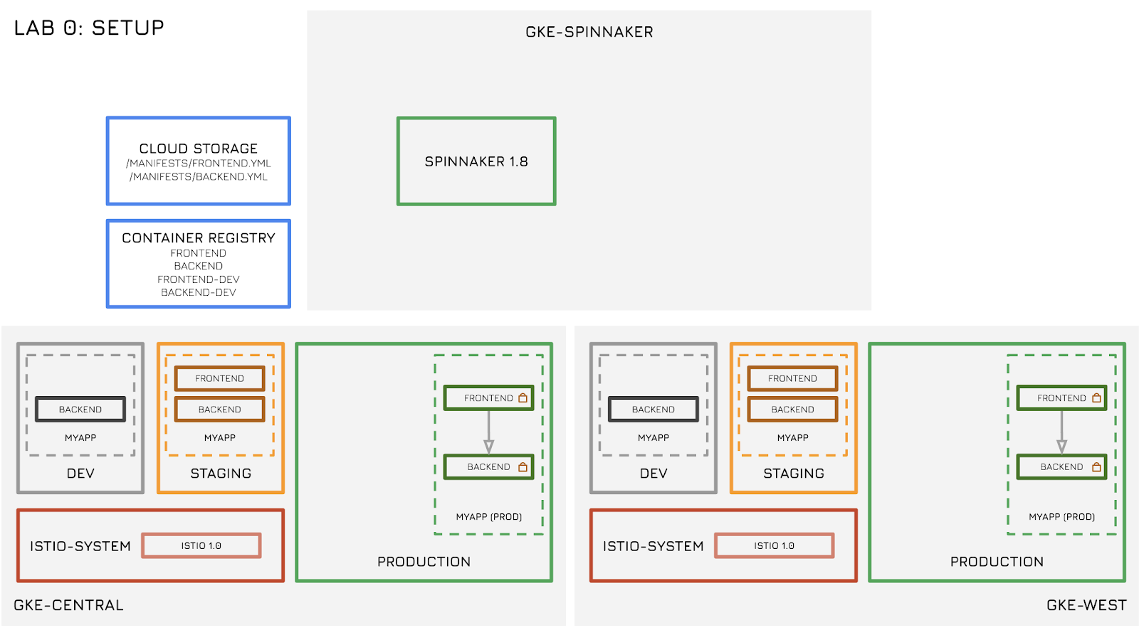

### Cloning the repo

Get all files associated with this workshop by cloning the following repo.

git clone https:*//github.com/reactiveops/advanced-kubernetes-workshop*

### Running install scripts

Run the following command to kick off the script to install all resources for this workshop.

source ~/advanced-kubernetes-workshop/setup/setup.sh

**Note**: This step takes about 20 - 25 minutes to complete. Please ensure you do not close Cloud Shell during the setup.

### Reviewing the environment

Once the script has finished, review the environment and ensure everything was installed properly.

#### Kubernetes Engine Clusters

Run the following command to ensure three Kubernetes Engine clusters were installed.

kubectx

Output (Do not copy)

gke-central

gke-west

gke-spinnaker

Confirm Istio is installed on gke-west and gke-central clusters. Ensure all services are up-to-date and available.

kubectl get deployments -n istio-system --context gke-west

kubectl get deployments -n istio-system --context gke-central

Output (Do not copy)

NAME DESIRED CURRENT UP-TO-DATE AVAILABLE AGE

grafana 1 1 1 1 1m

istio-citadel 1 1 1 1 1m

istio-egressgateway 1 1 1 1 1m

istio-galley 1 1 1 1 1m

istio-ingressgateway 1 1 1 1 1m

istio-pilot 1 1 1 1 1m

istio-policy 1 1 1 1 1m

istio-sidecar-injector 1 1 1 1 1m

istio-statsd-prom-bridge 1 1 1 1 1m

istio-telemetry 1 1 1 1 1m

istio-tracing 1 1 1 1 1m

prometheus 1 1 1 1 1m

servicegraph 1 1 1 1 1m

Confirm Spinnaker is installed on gke-spinnaker cluster. Ensure all services are up-to-date and available.

kubectl get deployments --context gke-spinnaker

Output (Do not copy)

NAME DESIRED CURRENT UP-TO-DATE AVAILABLE AGE

spin-clouddriver 1 1 1 1 2m

spin-deck 1 1 1 1 2m

spin-echo 1 1 1 1 2m

spin-front50 1 1 1 1 2m

spin-gate 1 1 1 1 2m

spin-igor 1 1 1 1 2m

spin-minio 1 1 1 1 5m

spin-orca 1 1 1 1 2m

spin-rosco 1 1 1 1 1m

Check namespaces in gke-west and gke-central clusters. Confirm ISTIO-INJECTION is enabled on both gke-central and gke-west for default, stagingand production namespaces.

kubectl get namespace -L istio-injection --context gke-central

kubectl get namespace -L istio-injection --context gke-west

Output (Do not copy)

NAME STATUS AGE ISTIO-INJECTION

default Active 1h enabled

dev Active 1h

istio-system Active 1h

kube-public Active 1h

kube-system Active 1h

production Active 1h enabled

spinnaker Active 1h

staging Active 1h enabled

#### Application

The application used in this workshop is composed of two microservices: frontendand backend. Both are web servers written in Go.

The application is installed in three namespaces on both clusters. production and staging namespaces are used for their named functions and dev namespace is used for local development.

Confirm the application is installed on both gke-west and gke-central clusters in all three namespaces.

kubectl get all -n production --context gke-central

kubectl get all -n staging --context gke-central

kubectl get all -n dev --context gke-central

kubectl get all -n production --context gke-west

kubectl get all -n staging --context gke-west

kubectl get all -n dev --context gke-west

Output excerpt for production namespace (Do not copy)

NAME DESIRED CURRENT UP-TO-DATE AVAILABLE AGE

deploy/backend-primary 5 5 5 5 1h

deploy/frontend-primary 5 5 5 5 1h

NAME TYPE CLUSTER-IP EXTERNAL-IP PORT(S) AGE

svc/backend ClusterIP 10.2.0.49 <none> 80/TCP 1h

svc/frontend ClusterIP 10.2.12.227 <none> 80/TCP 1h

Output excerpt for staging namespace (Do not copy)

NAME DESIRED CURRENT UP-TO-DATE AVAILABLE AGE

deploy/backend-primary 5 5 5 5 1h

deploy/frontend-primary 5 5 5 5 1h

NAME TYPE CLUSTER-IP EXTERNAL-IP PORT(S) AGE

svc/backend ClusterIP 10.2.12.194 <none> 80/TCP 1h

svc/frontend ClusterIP 10.2.14.225 <none> 80/TCP 1h

Output excerpt for dev namespace (Do not copy)

NAME DESIRED CURRENT UP-TO-DATE AVAILABLE AGE

deploy/backend-deploy-dev 1 1 1 1 1h

NAME TYPE CLUSTER-IP EXTERNAL-IP PORT(S) AGE

svc/backend-svc-dev ClusterIP 10.2.13.66 <none> 80/TCP 1h

svc/frontend-svc-dev LoadBalancer 10.2.4.239 35.224.34.160 80:32430/TCP 1h

The production and staging namespaces look exactly the same. Both frontendand backend deployments have 5 replicas and both services are exposed as ClusterIP (you use Istio ingressgateway in Lab 3 to expose these externally). The dev namespace only has a single replica deployment for both services and the frontend service is being exposed as service type LoadBalancer to quick be able to access it externally during local development phase.

#### Google Container Registry

Ensure that you have four images in GCR.

gcloud container images list

Output (Do not copy)

NAME

gcr.io/qwiklabs-gcp-04480262ec37ae63/backend

gcr.io/qwiklabs-gcp-04480262ec37ae63/backend-dev

gcr.io/qwiklabs-gcp-04480262ec37ae63/frontend

gcr.io/qwiklabs-gcp-04480262ec37ae63/frontend-dev

The frontend and backend images are used for staging and productionnamespace deployments. frontend-dev and backend-dev images are used for local development. This is discussed further in Lab 1.

#### Google Cloud Storage

Ensure you have the kubernetes manifests in Google Cloud Storage.

export PROJECT=$(gcloud info --format='value(config.project)')

gsutil ls gs:*//$PROJECT-spinnaker/manifests*

Output (Do not copy)

gs://qwiklabs-gcp-04480262ec37ae63-spinnaker/manifests/backend.yml

gs://qwiklabs-gcp-04480262ec37ae63-spinnaker/manifests/frontend.yml

Each of the yml files correspond to the respective microservice of the application. This is discussed further in Lab 2.

#### Google Cloud PubSub

Ensure you have topics and subscriptions created in your GCP Project for **GCR** and **GCS**. This is discussed further in Lab 2.

gcloud pubsub topics list

Output (Do not copy)

---

name: projects/qwiklabs-gcp-04480262ec37ae63/topics/gcr

---

name: projects/qwiklabs-gcp-04480262ec37ae63/topics/spin-gcs-topic

And

gcloud pubsub subscriptions list

Output (Do not copy)

---

ackDeadlineSeconds: 10

messageRetentionDuration: 604800s

name: projects/qwiklabs-gcp-04480262ec37ae63/subscriptions/my-gcs-sub

pushConfig: {}

topic: projects/qwiklabs-gcp-04480262ec37ae63/topics/spin-gcs-topic

---

ackDeadlineSeconds: 10

messageRetentionDuration: 604800s

name: projects/qwiklabs-gcp-04480262ec37ae63/subscriptions/my-gcr-sub

pushConfig: {}

topic: projects/qwiklabs-gcp-04480262ec37ae63/topics/gcr

### Exposing service ports

In this workshop, you access various Kubernetes add-ons using [kubectl port-forward](https://kubernetes.io/docs/tasks/access-application-cluster/port-forward-access-application-cluster/" \t "_blank)functionality. Here is a list of services and their respective ports for access for both gke-west and gke-central clusters.

|  |  |  |  |
| --- | --- | --- | --- |
| **Service** | **gke-central port** | **gke-west port** | **gke-spinnaker port** |
| Spinnaker | - | - | 8080 |
| Prometheus | 9000 | 9001 | - |
| Grafana | 3000 | 3001 | - |
| Jaeger | 16686 | 16687 | - |
| Servicegraph | 8088 | 8089 | - |

Run the following script to expose all of these port.

workshop\_connect

Output (Do not copy)

Spinnaker Deck Port opened on 8080

Prometheus Port opened on 9090 for GKE Central

Prometheus Port opened on 9091 for GKE East

Grafana Port opened on 3000 for GKE Central

Grafana Port opened on 3001 for GKE East

Jaeger Port opened on 16686 for GKE Central

Jaeger Port opened on 16687 for GKE East

Servicegraph Port opened on 8088 for GKE Central

Servicegraph Port opened on 8089 for GKE East

Congratulations! You have successfully installed all the pertinents components required for this workshop.

### Troubleshooting Lab 0

If you run into problems once the script has run, there are a few steps you can try to recover on your own.

First, try re-running the setup script. It will go much more quickly the second time:

source ~/advanced-kubernetes-workshop/setup/setup.sh

Next, you can at any time re-run the terraform used to setup most of the lab:

workshop\_terraform-apply

## END OF LAB 0 - Please STOP and wait for instructions before proceeding!

## Lab 1: Build (45 mins)

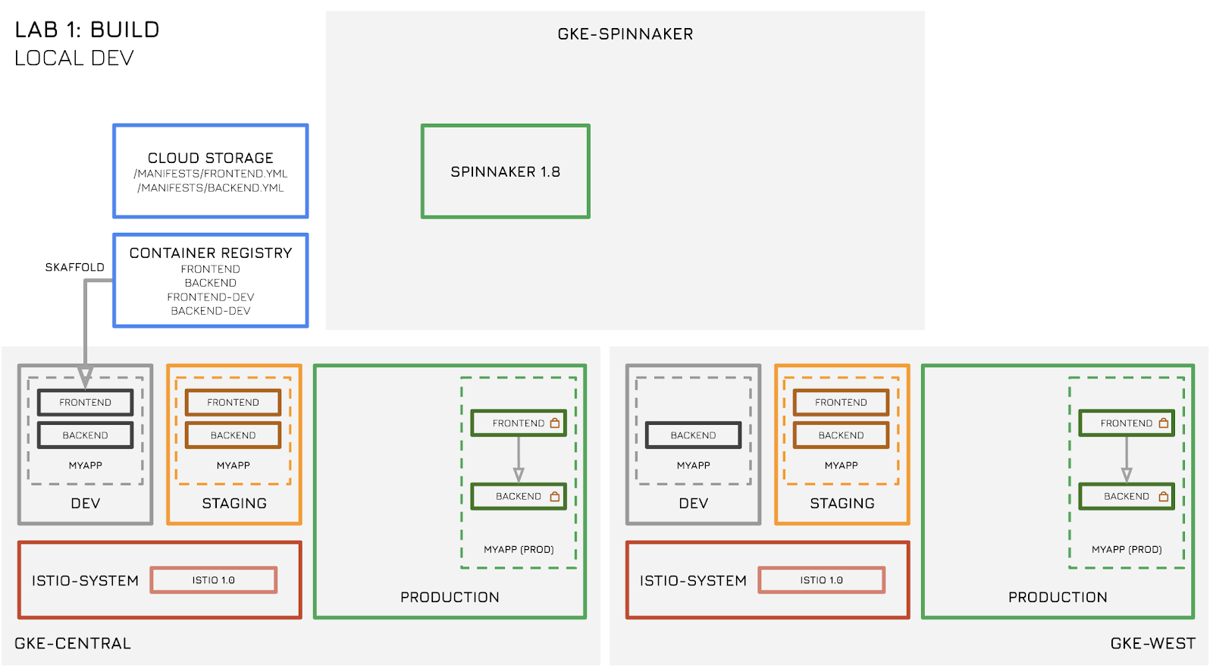

In this lab, you:

* Build and iterate on the web application.
* Use [Skaffold](https://github.com/GoogleContainerTools/skaffold" \t "_blank) for local development. Iterate, build ,deploy and test using Skaffold.
* Use dev namespace for local development.
* Clean up dev namespace after local development.

Developers typically build applications on their laptops. For developing on Kubernetes, sometimes [minikube](https://kubernetes.io/docs/setup/minikube/" \t "_blank) is used which is a single node Kubernetes cluster that runs locally on a laptop. Alternatively, you can use any Kubernetes cluster for local development. For this lab, you use gke-central cluster and namespace devfor local development.

### Inspecting the current dev environment

Check your current dev namespace and environment.

kubectl get all -n dev --context gke-central

Output excerpt (Do not copy)

NAME DESIRED CURRENT UP-TO-DATE AVAILABLE AGE

deploy/backend-deploy-dev 1 1 1 1 1h

NAME READY STATUS RESTARTS AGE

po/backend-deploy-dev-745858bcdc-8hnfx 1/1 Running 0 2h

NAME TYPE CLUSTER-IP EXTERNAL-IP PORT(S) AGE

svc/backend-svc-dev ClusterIP 10.2.13.66 <none> 80/TCP 1h

svc/frontend-svc-dev LoadBalancer 10.2.4.239 35.224.34.160 80:32430/TCP 1h

The only thing currently running is a single replica of backend deployment. There is no frontend deployment currently running. You can also see a service exposing the (future) frontend service via a LoadBalancer. The EXTERNAL-IP of that LoadBalancer will be used to access the dev environment.

You can now make changes to your frontend. You use Skaffold for this task.

Skaffold is a command line tool that facilitates continuous development for Kubernetes applications. You can iterate on your application source code locally then deploy to local or remote Kubernetes clusters. Skaffold handles the workflow for building, pushing and deploying your application.

Navigate to the frontend folder.

cd ~/advanced-kubernetes-workshop/services/frontend/

List files in folder.

ls -l

Output (Do not copy)

total 36

-rwxr-xr-x 1 googlece9765\_student googlece9765\_student 134 Sep 5 09:22 build.sh

-rwxr-xr-x 1 googlece9765\_student googlece9765\_student 102 Sep 5 09:22 check.sh

drwxr-xr-x 2 googlece9765\_student googlece9765\_student 4096 Sep 5 09:22 content

-rw-r--r-- 1 googlece9765\_student googlece9765\_student 150 Sep 5 09:22 Dockerfile

-rw-r--r-- 1 googlece9765\_student googlece9765\_student 818 Sep 5 09:23 k8s-frontend-dev.yml

-rw-r--r-- 1 googlece9765\_student googlece9765\_student 1206 Sep 5 09:22 main.go

-rw-r--r-- 1 googlece9765\_student googlece9765\_student 283 Sep 5 09:23 skaffold.yaml

-rw-r--r-- 1 googlece9765\_student googlece9765\_student 146 Sep 5 09:22 update-frontend.sh

The frontend service is composed of two files.

1. main.go file containing the source code
2. index.html file inside the content subfolder, which presents the frontendwebpage

Review the Dockerfile for the frontend service. This is the file used for building the container. Skaffold uses this for its build phase.

cat Dockerfile

Output (Do not copy)

FROM golang

ADD . /go/src/spinnaker.io/demo/k8s-demo

RUN go install spinnaker.io/demo/k8s-demo

ADD ./content /content

ENTRYPOINT /go/bin/k8s-demo

Skaffold also uses two additional YAML files.

1. skaffold.yaml which consists the build, push and deploy configurations for skaffold.
2. k8s-frontend-dev.yml which consists of the frontend-dev deployment yaml.

Review the skaffold.yaml file. The build, deploy and profiles sections correspond to artifacts, kubernetes deployment and container registry details respectively.

cat skaffold.yaml

Output (Do not copy)

apiVersion: skaffold/v1alpha2

kind: Config

build:

artifacts:

- imageName: gcr.io/qwiklabs-gcp-04480262ec37ae63/frontend-dev

deploy:

kubectl:

manifests:

- k8s-\*

profiles:

- name: gcb

build:

googleCloudBuild:

projectId: qwiklabs-gcp-04480262ec37ae63

Review the k8s-frontend-dev.yml file. This looks like a typical single replica kubernetes deployment and configmap. The configmap sets an environment variable that points to the backend-dev service address.

cat k8s-frontend-dev.yml

Output (Do not copy)

---

apiVersion: v1

kind: ConfigMap

metadata:

name: frontend-config-dev

namespace: dev

data:

BACKEND\_ENDPOINT: 'http://backend-svc-dev.dev'

---

apiVersion: apps/v1beta2

kind: Deployment

metadata:

name: frontend-deploy-dev

namespace: dev

labels:

app: frontend

version: dev

stack: frontend

tier: dev

spec:

replicas: 1

selector:

matchLabels:

app: frontend

version: dev

stack: frontend

tier: dev

template:

metadata:

labels:

app: frontend

version: dev

stack: frontend

tier: dev

spec:

containers:

- name: primary-dev

image: gcr.io/qwiklabs-gcp-04480262ec37ae63/frontend-dev

ports:

- containerPort: 8000

envFrom:

- configMapRef:

name: frontend-config-dev

### Developing with Skaffold

For this lab, you use two Cloud Shell terminal windows. Open another Cloud Shell window by clicking the plus button next to the existing Cloud Shell window.



Ensure you are in the ~/advanced-kubernetes-workshop/services/frontend in both Cloud Shell windows.

cd ~/advanced-kubernetes-workshop/services/frontend/

From Cloud Shell window # 1, switch to gke-central cluster context and run Skaffold in dev mode by running the following command.

kubectx gke-central

kubectl config set-context $(kubectl config current-context) --namespace=dev

skaffold dev

Output (Do not copy)

Starting build...

Building [gcr.io/qwiklabs-gcp-04480262ec37ae63/frontend-dev]...

...

...

Build complete in 44.728100636s

Starting deploy...

configmap "frontend-config-dev" created

deployment "frontend-deploy-dev" created

Deploy complete in 3.268022353s

[frontend-deploy-dev-fbc9fccc4-7qc4p primary-dev] Starting to service on port :8000

Skaffold builds the image and stores it in GCR in the frontend-dev image. After the build it deploys the k8s-frontend-dev.yml manifests which deploys the configmap and the deployment.

In the Cloud Shell window #2, confirm that the frontend-dev deployment is up and running in the dev namespace in the gke-central cluster.

kubectl get deploy -n dev --context gke-central

Output (Do not copy)

NAME DESIRED CURRENT UP-TO-DATE AVAILABLE AGE

backend-deploy-dev 1 1 1 1 3h

frontend-deploy-dev 1 1 1 1 3m

Get the frontend-dev service EXTERNAL-IP address.

kubectl get svc -n dev --context gke-central

Output (Do not copy)

NAME TYPE CLUSTER-IP EXTERNAL-IP PORT(S) AGE

backend-svc-dev ClusterIP 10.2.13.66 <none> 80/TCP 3h

frontend-svc-dev LoadBalancer 10.2.4.239 35.224.34.160 80:32430/TCP 3h 3m

Open a new Chrome tab and copy/paste the EXTERNAL-IP address in the new tab.

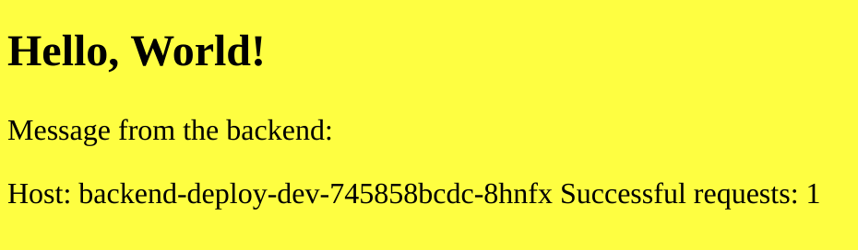

You can see the current frontend web page. The frontend shows a "hello world" page with the hostname of the backend it is currently talking to, as well as the number of successful requests (if you refresh the page a few times **CTRL-R**, you can see that number increase).

For this lab, let's change the background color from yellow to green.

You can either use "vi" or the Cloud Shell built in [Code Editor](https://cloud.google.com/shell/docs/features#code_editor) (IDE style editor) to edit the index.html file in the content folder. To open the Code Editor from Cloud Shell, click on the pencil icon on the right hand side of the Cloud Shell top bar.



Alternatively, you change the color in the background using the following command.

sed -i -e s/yellow/green/g $HOME/advanced-kubernetes-workshop/services/frontend/content/index.html

Switch back to Cloud Shell window #1 (where skaffold dev is running). Notice that the build and deploy process has restarted when the file index.html changed. Whenever skaffold detects a file system change (for instance changing the index.html file), it builds and deploys the new change instantly without the developer having to manually delete the old deployment, rebuild the new image and redeploy the manifest.

Confirm the change in color.

cat $HOME/advanced-kubernetes-workshop/services/frontend/content/index.html

Output (Do not copy)

<!DOCTYPE html>

<html>

<body style="background-color:green">

<h2>Hello, World!</h2>

<p>Message from the backend:</p>

<p>{{.Message}}</p>

<p>{{.Feature}}</p>

</body>

</html>

Confirm the change by refreshing the frontend web page.

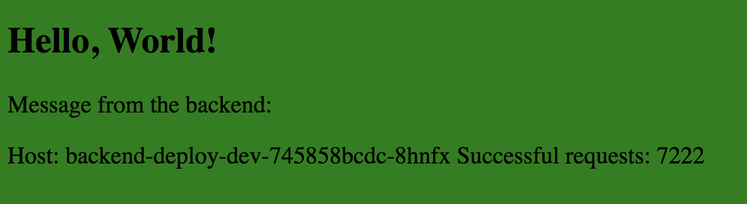

This change is only applied to the dev version of the frontend.

To confirm this, get the ingress IP addresses for the production frontend by running the following command.

workshop\_get-ingress

Output (Do not copy)

gke-central ingress gateway:

35.202.138.224

gke-west ingress gateway:

35.236.250.232

Open a new Chrome tab and type the IP address on the gke-central ingress gateway in the new tab.

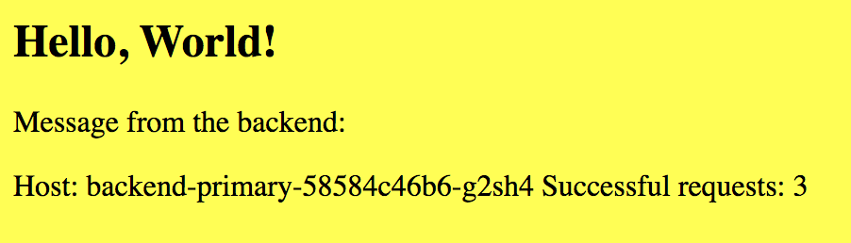

The production frontend still shows yellow background. You can also see the hostname of the backend which is pointing to the primary backend deployment.

**Note**: You can confirm the hostname by looking at the pods in the production namespace of the gke-central cluster.

kubectl get pods -n production --context gke-central

Optionally, you can change the color from green to something else (i.e. blue, purple, magenta, cyan etc) and watch skaffold rebuild and redeploy the new change instantly.

Once you are satisfied with your choice of color, exit out of skaffold dev command using **CTRL-C** key combination.

Exiting Skaffold deletes any artifacts deployed as part of skaffold dev.

Output (Do not copy)

Cleaning up...

configmap "frontend-config-dev" deleted

deployment "frontend-deploy-dev" deleted

Cleanup complete in 3.820695597s

Confirm by running the following command.

kubectl config set-context $(kubectl config current-context) --namespace=default

kubectl get pods -n dev --context gke-central

Output (Do not copy)

NAME READY STATUS RESTARTS AGE

backend-deploy-dev-745858bcdc-8hnfx 1/1 Running 0 9h

Close the Chrome tab for the frontend-dev webpage.

Congratulation! You can successfully iterate applications live on Kubernetes using Skaffold local development tool.

## END OF LAB 1 - Please STOP and wait for instructions before proceeding!

## Lab 2: Deploy (45 mins)

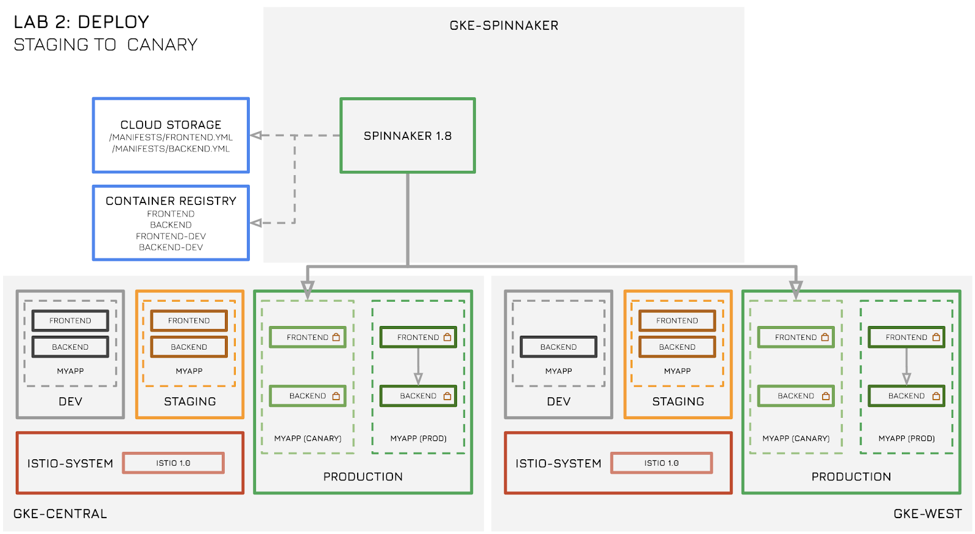

In this lab, you:

* Build the new image using Cloud Build.
* Use PubSub to trigger the Spinnaker pipeline.
* Deploy the new application frontend via Spinnaker to the gke-west and gke-central clusters.
* Deploy the new application frontend in staging namespace.
* Deploy the new application frontend as canary in the production namespace.

### Configuring Spinnaker pipelines

Ensure that you are port-forwarding all the required services using the workshop\_connect command. If you are unsure, re-run the script again by running the following command.

workshop\_connect

One of the services as part of Spinnaker is Deck. Deck is the web frontend for Spinnaker. To access the Spinnaker user interface, click **Web Preview** in Cloud Shell (top bar, right hand side) and click **Preview on port 8080**.

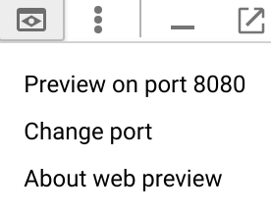

You get the Spinnaker GUI with the header as shown.



Click on **Applications** in the header and select the application labeled **myapp**. Note that **myapp** might be on page 2 of the Applications list.

You can see the two clusters gke-central and gke-west, with frontend and backend deployments (5 replicas each) in the production and stagingnamespaces. Each green rectangle represents a pod.

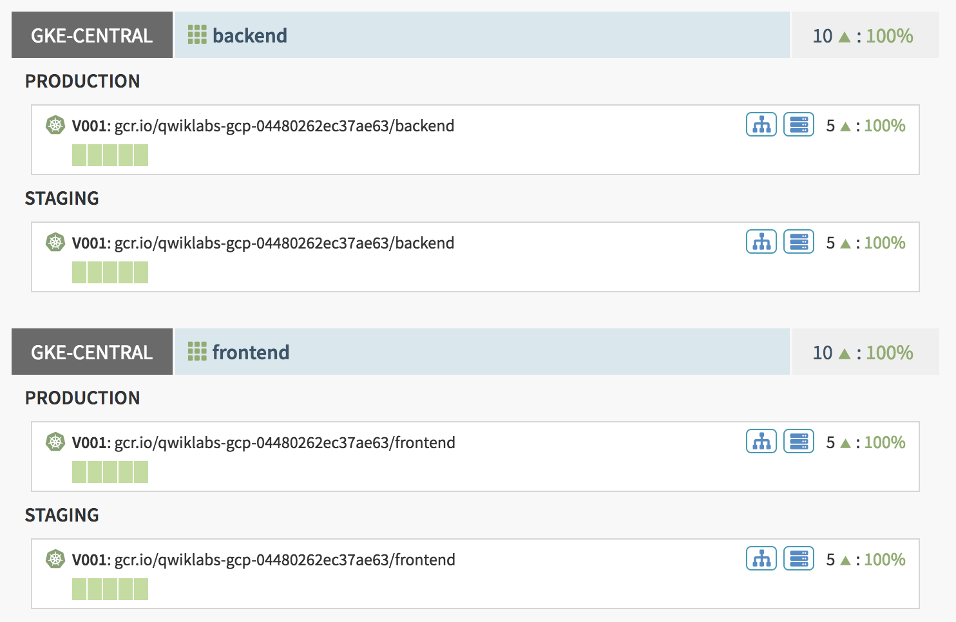

Click on **PIPELINES** in the header. You see no pipelines currently deployed.

Deploy Spinnaker pipelines by running the following commands in Cloud Shell.

workshop\_create-pipelines

Refresh the Spinnaker pipelines page using **CTRL-R** key combination. You see two pipelines.

Both pipelines are identical for the two clusters: one for gke-central and one for gke-west.

Inspect the pipeline for the gke-central cluster. Click on the **Configure** link for the **Central - Staging - Canary - Production** pipeline.



Inspect the pipelines by clicking on various stages.

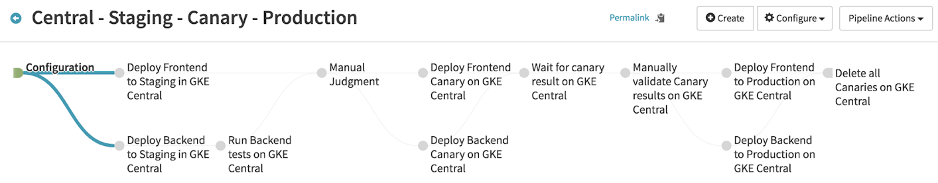

#### Configuration

The initial **Configuration** stage defines the triggers and expected artifacts for the pipeline. You see two triggers of type Google PubSub: one for **GCR** and one for **GCS**. Whenever there is a change either to the GCR repositories (for frontend or backend), or to the kubernetes manifests files stored in GCS, the pipeline is triggered. The **Expected Artifacts** section describes which artifacts will be used in the current pipeline. You see the two images: for frontend and backend. You also see the two manifests files frontend.yml and backend.yml (stored in a GCS bucket).

#### Deploy to Staging

The next two stages update the frontend and backend deployment in the stagingnamespace. These stages use the respective manifests files from the GCS bucket. It is recommended to store the Kubernetes manifests in a storage bucket instead of hard coding them in Spinnaker so that they may be version controlled as you make changes to them. Inspect the manifests files by running the following command in Cloud Shell.

export PROJECT=$(gcloud info --format='value(config.project)')

gsutil cat gs:*//$PROJECT-spinnaker/manifests/frontend.yml*

gsutil cat gs:*//$PROJECT-spinnaker/manifests/backend.yml*

The output shows template stylized kubernetes manifests using [Spinnaker Pipeline Expressions](https://www.spinnaker.io/guides/user/pipeline/expressions/). Expressions allow you to use the same manifests files for various stages / phases of the application lifecycle.

#### Testing Backend

The following stage tests the backend service by performing a curl to the service FQDN. This stage uses a hard coded text box (instead of GCS stored manifests) for the Kubernetes job object. Unlike the Kubernetes manifests, this job object may not change which makes it ok to be hard coded as text.

In addition to the Job object, you also see a Policy object. This is a Kubernetes CRD ([Custom Resource Definition](https://kubernetes.io/docs/concepts/extend-kubernetes/api-extension/custom-resources/)) defined by Istio (discussed in more detail in the Lab 3). The current implementation of Istio injects a [sidecar proxy](https://istio.io/docs/concepts/what-is-istio/#architecture) in each pod which encrypts all traffic (service to service) using mTLS (mutual TLS). You can disable mTLS on a per-service basis using the Policy object. This allows the staging backend service to not use mTLS. Furthermore, the Job object has the following annotation:

sidecar.istio.io/inject: 'false'

This prohibits the Istio sidecar to be injected in this pod. Bypassing mTLS using Policy object coupled with the annotated Job object allows for the Job to do a simple curl to the backend service.

#### Manual Judgement

After both the frontend and backend deployments have been updated in the staging namespace, there is a **manual judgement** stage which waits for admin intervention to proceed to the next step.

#### Deploy Canary to Production

The next stage updates the frontend and backend deployment in productionnamespace as [canary](https://featureflags.io/canary-testing/). Canary Deployments (or Canary Testing) is a way to test software in production by deploying the new (updated) version of a service in production environment and routing a subset of traffic to it. This stage deploys one replica of the frontend and backend each (as opposed to five for production). Using Spinnaker pipeline expressions, you can use the same manifest files as before, and change certain fields like labels and replicas to adjust for the current stage.

#### Manual Judgement

After the canary stage, there is yet another **manual judgement** stage prior to promoting to production.

#### Promote to Production

Once the canary release has been tested and verified, you promote the canary release to production, making it the new production version, using the same manifest files and taking advantage of Spinnaker pipeline expressions.

#### Delete all canaries

Lastly, delete all canary deployments in the production namespace.

Once you inspect each stage, exit out of the pipeline configuration screen by clicking the back arrow next to the pipeline name.



### Building the image

Next you build the new frontend image (from Lab 1) using **Cloud Build** by running the following commands in Cloud Shell.

cd ~/advanced-kubernetes-workshop/services/frontend/

./build.sh

The script builds the new image and stores it in GCR.

### Deploying to staging

The build from the previous step causes Spinnaker pipelines to be triggered (recall the Spinnaker pipelines are set to trigger whenever there is a new image uploaded to GCR).

Inspect the running pipelines from the Spinnaker GUI.

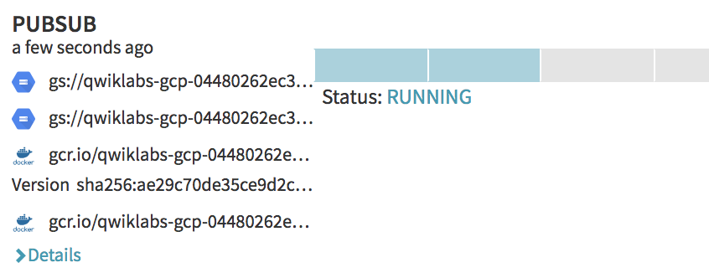

You see the cause of the trigger as **PUBSUB** and the status of each stage (represented by individual rectangles). Blue color signifies stage in progress while green means a successful completion of the stage. Hovering over the rectangle reveals the name of the stage. You can also click on the stage (rectangle) and get further details into tasks and subtasks being performed during the stage.

After a few moments, you see a person icon representing the **MANUAL JUDGEMENT**stage.

Do **NOT** click Continue yet.

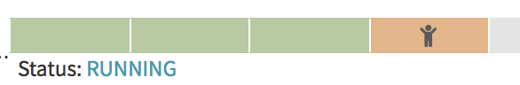

Hover over the orange rectangle and you see certain instructions and an option to Continue or Stop.

Click on **INFRASTRUCTURE** in the top panel. From the left side panel, under Account, select **gke-central** and under Region, select **staging**.

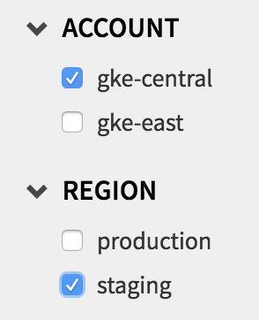

You can see **V002** for both frontend and backend deployments. The **V\*** tags are internal Spinnaker tags to keep track of updates. Every time the pipeline is triggered, the **V\*** versions tags are incremented. You can also see the SHA signature for the new frontend image. Backend image remained the same as no changes were made to it.

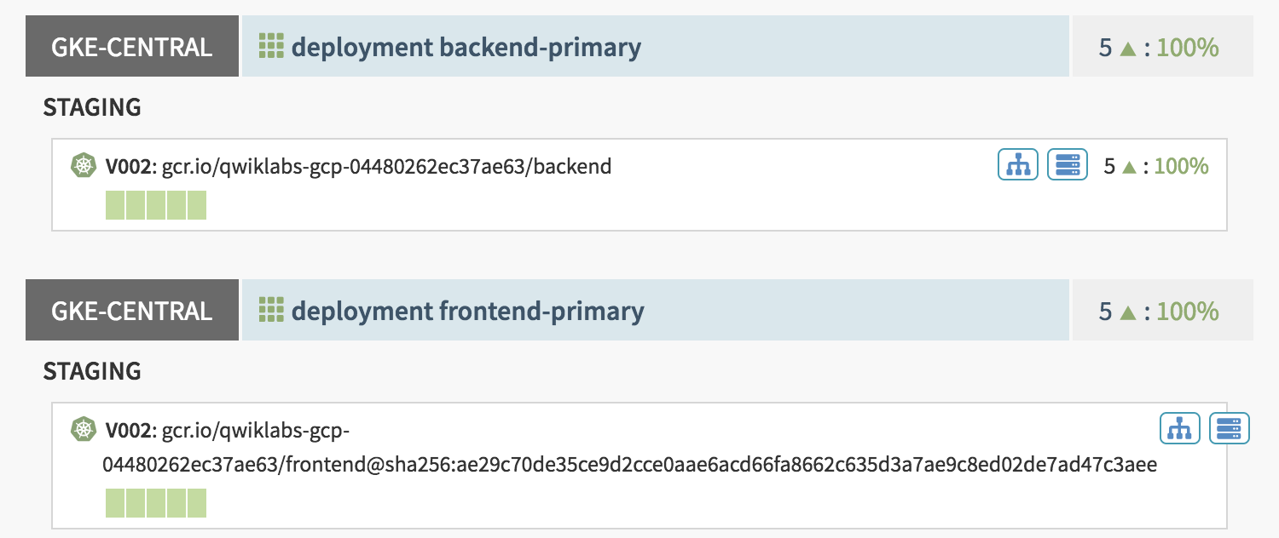

You also see **V001** deployments (previous versions of the staging deployments prior to the current execution of the pipeline). Both the frontend and backend **V001**deployments have **0** replicas however, they are still present in case you want to roll back.

### Deploying canaries to production

Click on the **PIPELINES** link from the top bar. Hover over the orange rectangles and click **Continue**. This causes the pipelines to continue to the next stage. The next stage deploys the frontend and backend in the production namespace as canaries. The successful completion of the following few stages will culminate with yet another **Manual Judgement** stage.

Do **NOT** click Continue yet!



Inspect the deployment by clicking on **INFRASTRUCTURE** link in the top bar. From the left hand side bar, under Account, select **gke-central** and under Region, select **production**.

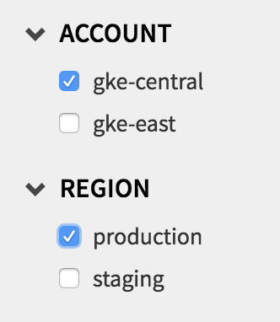

You now see that in addition to the primary production deployment, there are two new canary deployments each containing a single replica. The **V001** (for the two canary deployments) indicate this is the first iteration of the canary releases for this pipeline.

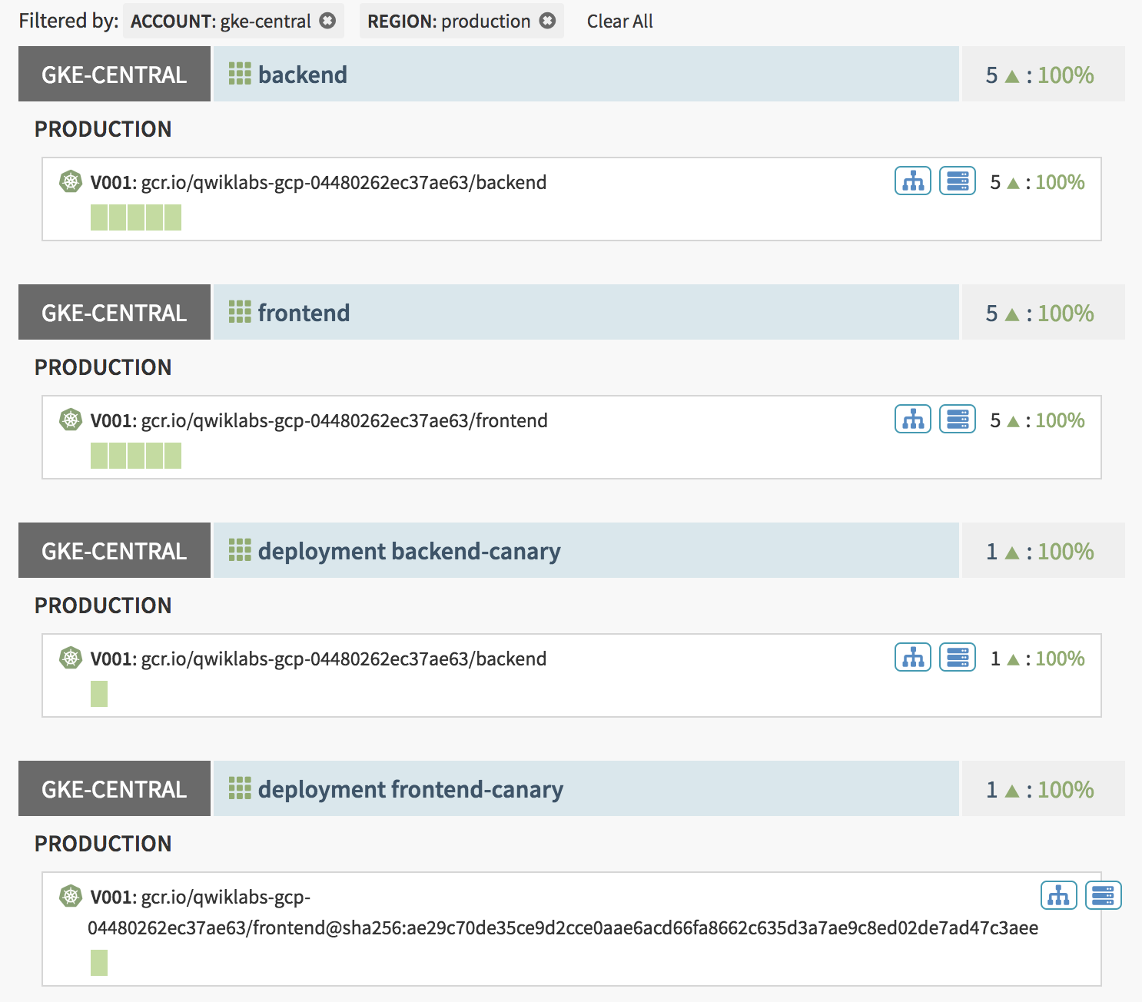

Click on any of the green rectangles of the **frontend** deployment and inspect the labels on the right hand side bar.

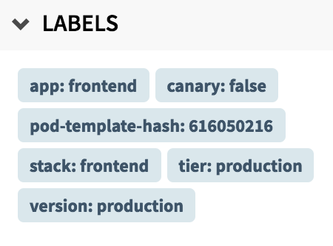

The two labels to take note of are **app: frontend** and **version: production**. Likewise, click on the single green rectangle of the **deployment frontend-canary** deployment. Inspect the labels from the right hand side bar.

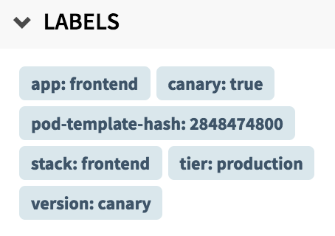

The two labels to take note of are **app: frontend** and **version: canary**. You use these labels and Istio in the next Lab for controlling traffic to the two versions.

Congratulations! You have successfully used Cloud Build to build the new image, deploy a Spinnaker pipeline, trigger the pipeline using PubSub and deploy the new image as canary.

### Troubleshooting Lab 2

If you run into problems with spinnaker such as missing pipelines, pubsub queues, or projects, don't forget that you can always run:

workshop\_hal-config

This will re-run the hal config scripts that setup spinnaker.

## END OF LAB 2 - Please STOP and wait for instructions before proceeding!

## Lab 3: Control (60 mins)

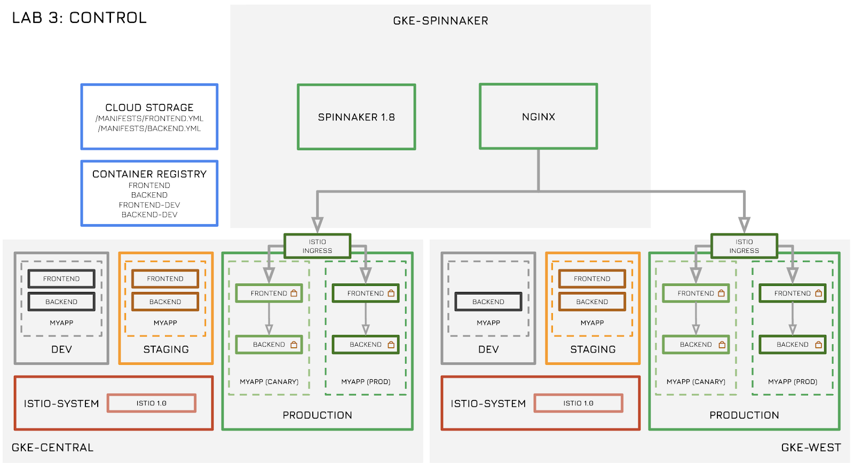

In this lab, you will:

* Use Istio Service Mesh for advanced traffic routing.
* Use Istio for policy and quota management.
* Use Istio for securing pod-to-pod communication using mTLS.
* Use Prometheus and Grafana for monitoring traffic and policy changes.
* Use NGINX for global load balancing to multiple kubernetes clusters.

### Istio Service Mesh

Istio is an open source framework for connecting, securing, and managing microservices, including services running on Kubernetes Engine. It lets you create a network of deployed services with load balancing, service-to-service authentication, monitoring, and more, without requiring any changes in service code.

In order to create the service mesh, Istio deploys a special sidecar proxy to each of your application's pods. This proxy intercepts all network communication between microservices and is configured and managed using Istio's control plane.

Istio's architecture looks as follows:

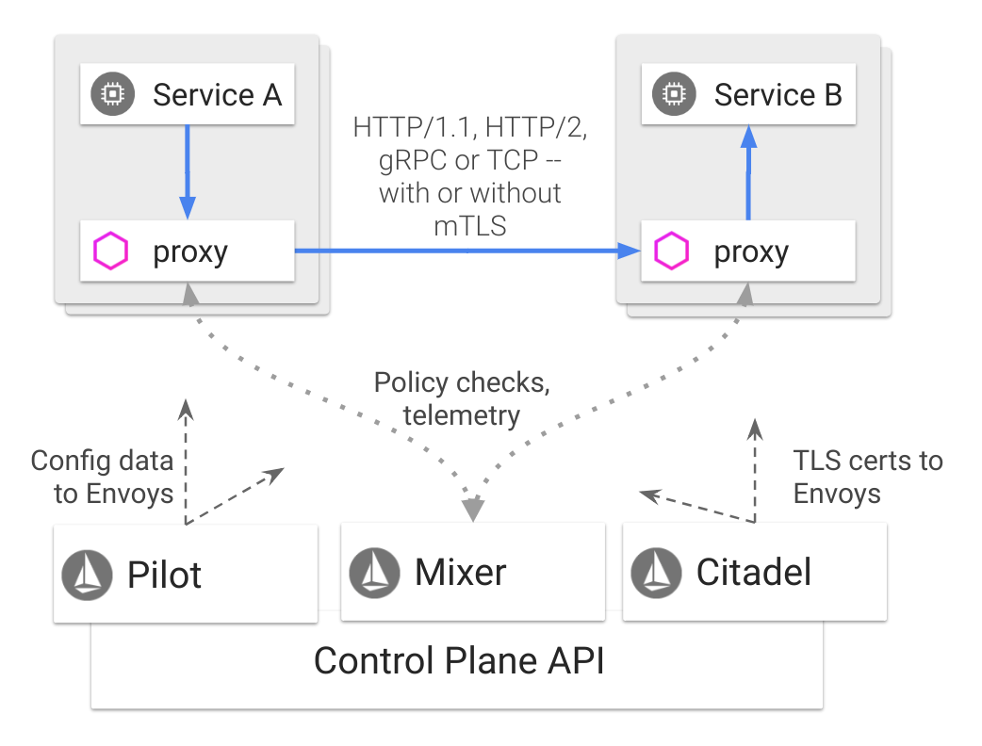

The Data plane consists of a mesh of sidecar proxies (powered by the [Envoy](https://www.envoyproxy.io/) proxy) deployed within each pod next to the service container. The sidecar proxy abstracts all of the application networking functionality (routing, security, policy and monitoring) from the service. The service has no knowledge of its underlying networking topology. It simply receives and sends traffic via its sidecar proxy. All proxies are interconnected in a full-mesh fashion thus making a service mesh. Proxies send and receive traffic from their sidecar service (also known as downstream service) to other proxies connected to other services (also known as upstream services) based on a set of configured rules. These rules are configured by the Istio Control plane.

The Istio Control plane consists of three components:

* **Pilot** is responsible for configuring the rules on the sidecar proxies within the mesh. For Kubernetes, these rules are typically configured using Istio CRDs which are in turn sent to each sidecar proxy in the mesh.
* **Mixer** is responsible for policy/quota management and enforcement as well as telemetry. All proxies synchronously check with the Mixer for allowances/policies as they communicate with other services. In Kubernetes, Mixer policies are typically configured via Istio CRDs. The proxies also asynchronously send telemetry information (metrics, traces etc) to mixer which can then be sent via plugins to another service. For example, one of the Istio add-ons is Prometheus which is a popular open source metrics collector. More on Prometheus in the next lab.
* **Citadel** is responsible for securing traffic within the service mesh. It provides a verifiable identity as well as encryption for service to service communication. It is responsible for managing, rotating and revoking certificates to each proxy within the mesh.

#### Ingress Gateway, VirtualServices, and DestinationRules

In Kubernetes, exposing services externally is typically done using the Kubernetes Ingress resource. Istio provides a more robust mechanism using [Istio Gateway](https://istio.io/docs/concepts/traffic-management/" \l "gateways" \t "_blank). An Istio Gateway operates at the edge of the service mesh and controls traffic into and out of the mesh. In GCP, it sets up a Google Cloud Load Balancer for ingress/egress traffic. A Gateway custom resource is used for configuration which can then be applied to a kubernetes service.

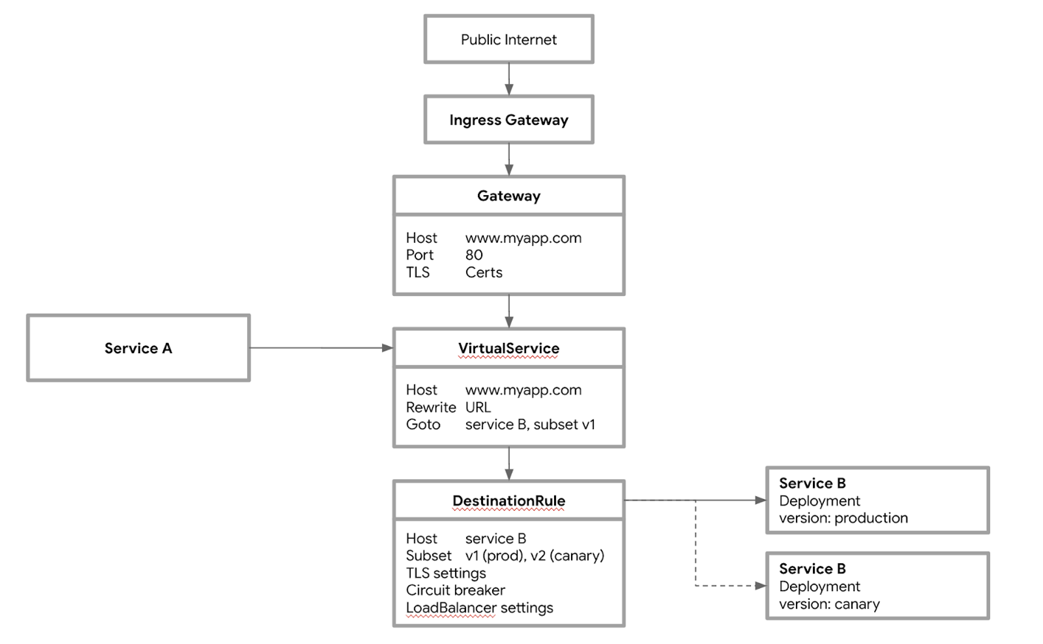

An Istio gateway is already created as part of the initial setup. Inspect the Gateway resource by running the following commands.

kubectl get gateway -n production --context gke-central -o yaml

Output (Do not copy)

apiVersion: networking.istio.io/v1alpha3

kind: Gateway

metadata:

...

name: frontend-gateway

namespace: production

...

spec:

selector:

istio: ingressgateway

servers:

- hosts:

- '\*'

port:

name: http

number: 80

protocol: HTTP

The name of the gateway is frontend-gateway. The selector spec selects which proxy the rule applies to. In this case, it applies to the istio ingressgateway which is deployed in the istio-system namespace as part of the istio installation.

The hosts field is set to wildcard ‘\*' which means this applies to all hostnames. This is done to make it easier for the workshop. In production, you would have actual hostnames defined in each gateway for example, **www.company.com** or **www.company.com/svcA** etc. In this case, the gateway will only be applied for the defined hosts.

The gateway can then be applied to a service. In Istio, you use the **VirtualService**concept, which corresponds to a Kubernetes service.

Inspect the frontend VirtualService by running the following command.

kubectl get virtualservice frontend -n production --context gke-central -o yaml

Output (Do not copy)

...

spec:

gateways:

- frontend-gateway

hosts:

- '\*'

http:

- route:

- destination:

host: frontend

port:

number: 80

The VirtualService has a single rule which send all traffic destined for HTTP port 80 to kubernetes service frontend. The gateways field is used to select the gateway defined in the previous step - frontend-gateway.

The last piece of the puzzle is the **DestinationRule**. A DestinationRule configures the set of policies to be applied to a request after VirtualService routing has occurred. They are intended to be authored by service owners, describing the circuit breakers, load balancer settings, TLS settings, and other settings.

A DestinationRule also defines addressable **subsets**, meaning named versions, of the corresponding destination host. These subsets are used in VirtualService route specifications when sending traffic to specific versions of the service. More on this in later sections.

Inspect the DestinationRule by running the following command.

kubectl get destinationrule frontend -n production --context gke-central -o yaml

Output (Do not copy)

...

spec:

host: frontend

subsets:

- labels:

version: canary

name: canary

- labels:

version: production

name: production

trafficPolicy:

loadBalancer:

simple: ROUND\_ROBIN

tls:

mode: ISTIO\_MUTUAL

The DestinationRule is defining two components for the frontend VirtualService. First is **subsets**, which define versions within a service. In Kubernetes, this can be thought of as multiple deployments running under a single service with different labels. For example, in this case, you have two deployments for frontend in the production namespace, one for primary (or production) traffic and one deployed as canary. These two deployments are distinguished by labels. Subset names canaryuses the label selector "version": "canary" and likewise subset named production uses the label selector "version": "production". The DestinationRule also defines a **trafficPolicy** which sets the load balancing policy to ROUND-ROBIN and TLS to use mTLS.

In the next section, you use VirtualServices to control traffic routing to specific versions of frontend and backend service.

#### Request Routing

In a typical multi-tier microservices architecture, you may have numerous services each running multiple versions. In this workshop, you have a two tier application and each tier is currently running two versions. You have two versions of frontendservice - primary and canary (running as two deployments) and two versions of backend service - primary and canary (running as two deployments).

Inspect the deployments in the gke-central cluster by running the following command.

kubectl get deploy -n production --context gke-central

Output (Do not copy)

NAME DESIRED CURRENT UP-TO-DATE AVAILABLE AGE

backend-canary 1 1 1 1 16h

backend-primary 5 5 5 5 1d

frontend-canary 1 1 1 1 16h

frontend-primary 5 5 5 5 1d

There are five pods for the primary (or production) deployments versus one pod for the canary deployments. Kubernetes uses basic round robin logic for load balancing traffic to different pods within a service. Since both deployments are under a single service, the two services send traffic to all 6 pods in a round robin fashion.

Get the Ingress gateway external IP address for the cluster by running the following script.

workshop\_get-ingress

Output (Do not copy)

gke-central ingress gateway:

35.202.138.224

gke-west ingress gateway:

35.236.250.232

Open a new Chrome tab and copy/paste the gke-central ingress gateway IP address. Continually refresh the page using **CTRL-R** and you can see both the primary (yellow background) and the canary deployments (green background).

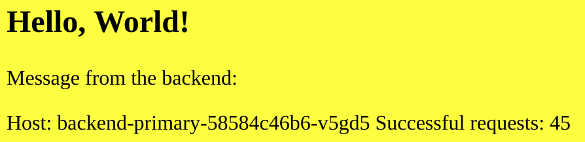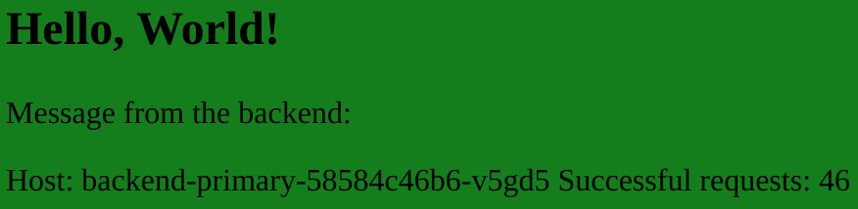

Create some load on the frontend using the **hey** utility.

For this task, open two Cloud Shell windows. In Cloud Shell window #1, start the **hey**traffic generator by running the following command.

export GKE\_ONE\_ISTIO\_GATEWAY=$(kubectl get svc istio-ingressgateway -n istio-system -o jsonpath="{.status.loadBalancer.ingress[0].ip}" --context gke-central)

hey -z 30m http:*//$GKE\_ONE\_ISTIO\_GATEWAY*

This command starts the hey test with default settings for 10 minutes.

**Note**: The **hey** traffic generator runs for 30 minutes. If you are still in this section, re-run the hey command to keep generating more traffic.

In order to view the service metrics, you can use **Grafana**. All metrics from Istio Mixer are fed into **Prometheus** (a metrics collector) and Grafana is a visualization tool used for Prometheus. More on this in the next lab.

Click **Web Preview** in Cloud Shell (top bar, right hand side) and click **Change port**.

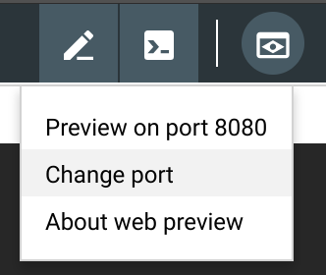

Change the port to **3000** and click **Change and Preview**. This opens a new tab in Chrome for Grafana.

Click on the **Home** button in the top left corner and then the **Istio Service Dashboard**link from the left hand side.

In the **Service** dropdown menu (top left corner), ensure that **backend.production.svc.cluster.local** is selected. Leave everything else as default. Inspect the **Incoming Requests by Source and Response Code** graph.

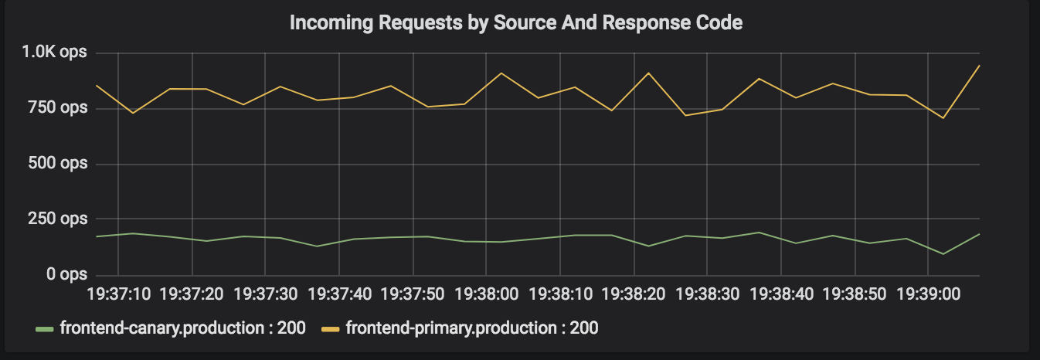

This shows traffic by frontend deployments. By default, traffic is being sent to both primary and canary versions of the frontend service. There are five primary pods and one canary pod hence more traffic (about five times more) is being sent to the primary pods vs canary. Scroll down and look at the **Incoming Requests by Destination and Response Code** graph. This shows the backend service and you can see a similar pattern to the frontend.

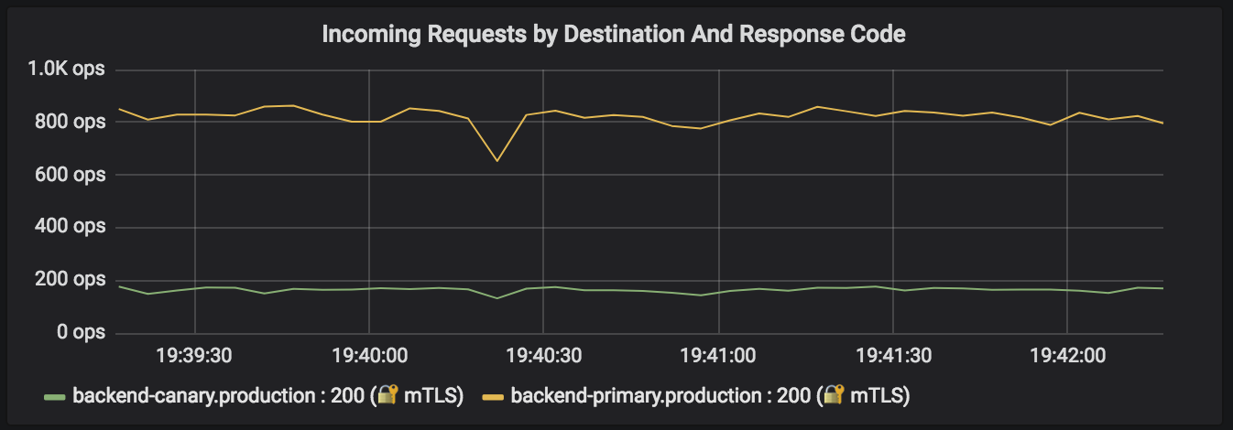

Currently, all frontend pods (primary and canary) can talk to all backend pods (primary and canary). There is no way of knowing which frontend will serve the client and also which backend will be served for every request. Apply a rule to send 50 percent of the client traffic to the primary frontend, and 50 percent of the client traffic to the canary frontend. Run the following command from the second Cloud Shell window.

kubectl apply -f ~/advanced-kubernetes-workshop/services/manifests/frontend-vs-50prod-50canary.yml --context gke-central

Output (Do not copy)

Updated config virtual-service/production/frontend to revision 276546

Inspect the new frontend VirtualService.

kubectl get virtualservice frontend -n production --context gke-central -o yaml

Output excerpt (Do not copy)

...

spec:

gateways:

- frontend-gateway

hosts:

- '\*'

http:

- route:

- destination:

host: frontend

port:

number: 80

subset: canary

weight: 50

- destination:

host: frontend

port:

number: 80

subset: production

weight: 50

Notice the subsets (defined in the DestinationRule) "canary" and "production"are getting 50% of the traffic each, defined by the "weight" field.

Confirm the rule is in effect by inspecting the **Incoming Requests by Source and Response Code** graph on Grafana.

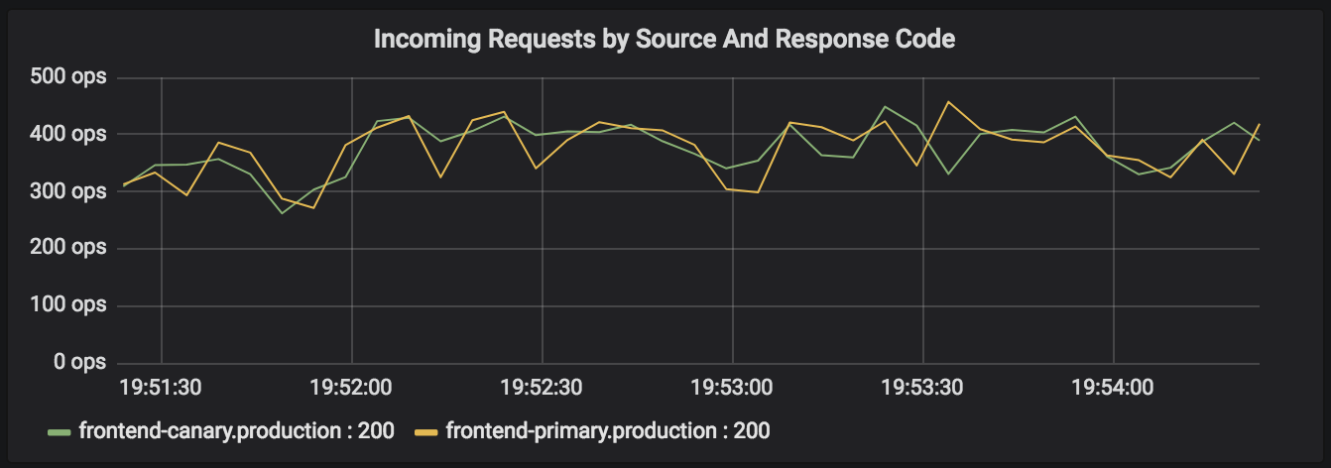

Notice that the **Incoming Requests by Destination and Response Code** graph remains the same. Can you guess why?

Regardless of which frontend version serves the client, the backend service is being load balanced in the default round robin manner. Apply a VirtualService rule for the backend service to only send primary (or production) frontend traffic to primary (or production) backend and canary frontend traffic to canary backend. Run the following command in the second Cloud Shell.

kubectl apply -f ~/advanced-kubernetes-workshop/services/manifests/backend-vs-can-to-can-prod-to-prod.yml --context gke-central

Output (Do not copy)

Updated config virtual-service/production/backend to revision 277689

Inspect the new backend VirtualService by running the following command.

kubectl get virtualservice backend -n production --context gke-central -o yaml

Output excerpt (Do not copy)

...

spec:

hosts:

- backend

http:

- match:

- sourceLabels:

app: frontend

version: canary

route:

- destination:

host: backend

port:

number: 80

subset: canary

- match:

- sourceLabels:

app: frontend

version: production

route:

- destination:

host: backend

port:

number: 80

subset: production

The rule matches the sourceLabel of app: frontend and version: canary and routes it to the subset canary of the backend service. Likewise, sourceLabel of app: frontend and version: production is routed of subset production of the backend service. Inspect the **Incoming Requests by Destination and Response Code** graph.

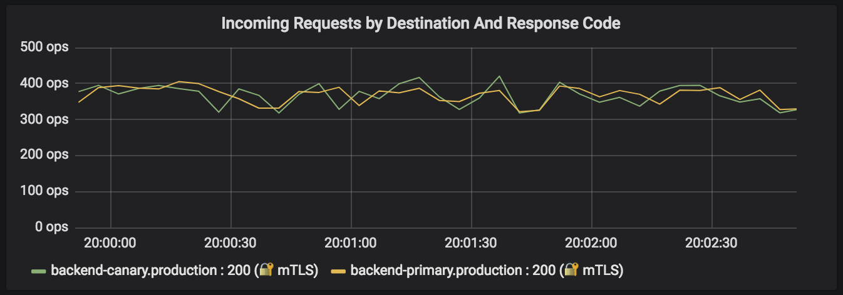

The incoming graph now looks identical to the **Incoming Requests by Source** graph.

There is still no way to be sure that the frontend production is going to backendproduction and vice versa.

Apply a frontend VirtualService rule to send 100% of the traffic to production frontend. Run the following command.

kubectl apply -f ~/advanced-kubernetes-workshop/services/manifests/frontend-vs-all-to-prod.yml --context gke-central

Output (Do not copy)

Updated config virtual-service/production/frontend to revision 278549

Inspect the new frontend VirtualService and confirm 100% of the traffic is now being sent to the production frontend..

kubectl get virtualservice frontend -n production --context gke-central -o yaml

Output excerpt (Do not copy)

...

spec:

...

http:

- route:

- destination:

host: frontend

port:

number: 80

subset: canary

- destination:

host: frontend

port:

number: 80

subset: production

weight: 100

Inspect both the Grafana charts to confirm that all traffic is going to the production frontend.

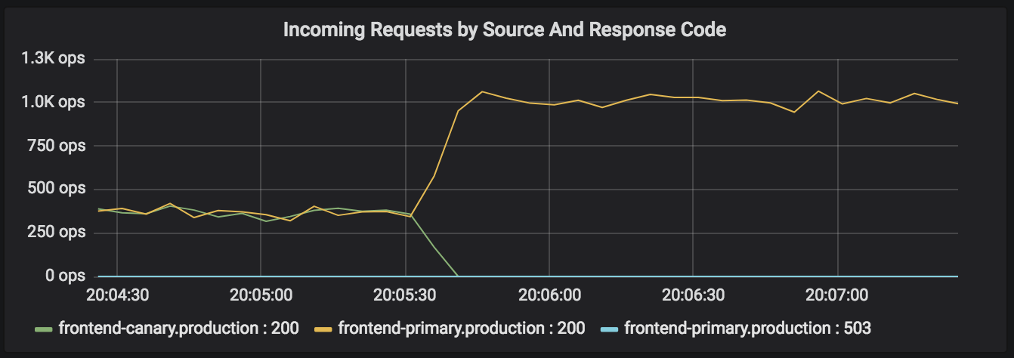

Since the backend VirtualService rule sends all production frontend traffic to production backend deployment, the **Incoming Requests by Destination** shows the same behavior.

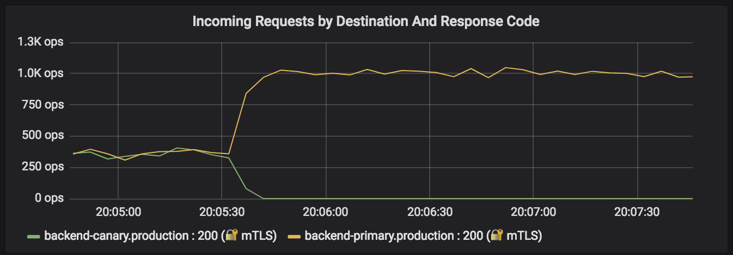

Finally, apply a frontend VirtualService rule to send 100% of the traffic to the canary frontend. Run the following command.

kubectl apply -f ~/advanced-kubernetes-workshop/services/manifests/frontend-vs-all-to-canary.yml --context gke-central

Output (Do not copy)

Updated config virtual-service/production/frontend to revision 279182

Inspect the new frontend VirtualService.

kubectl get virtualservice frontend -n production --context gke-central -o yaml

Output excerpt (Do not copy)

...

spec:

...

http:

- route:

- destination:

host: frontend

port:

number: 80

subset: canary

weight: 100

- destination:

host: frontend

port:

number: 80

subset: production

Inspect the two Grafana graphs and confirm the behavior as expected.

100% of the frontend traffic is now going to the canary frontend.

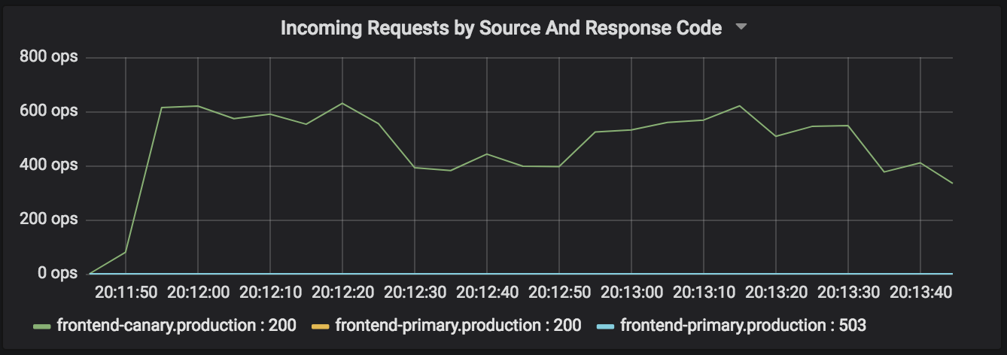

As expected, 100% of the backend traffic to going to the canary backend.

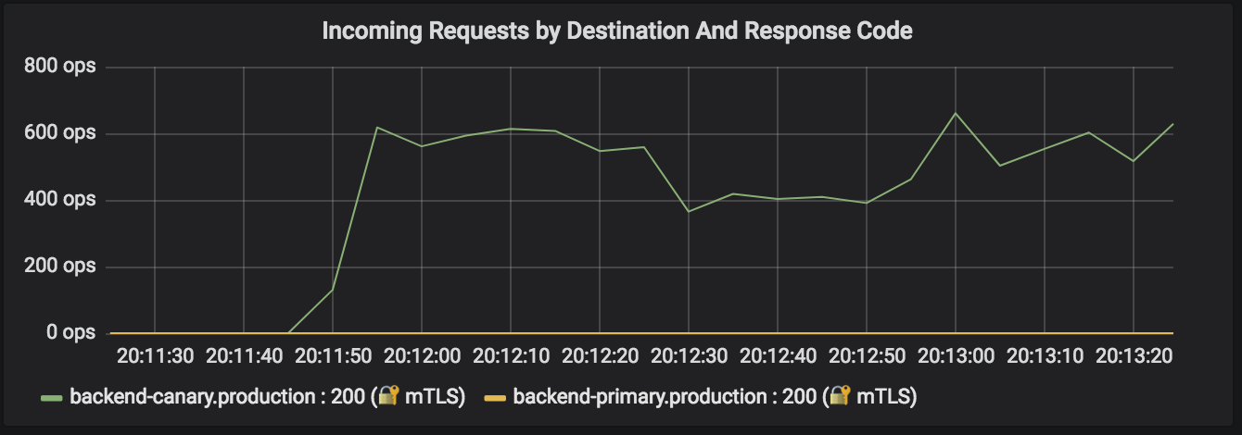

Using match filters and subset weights, you have full control over service to service traffic routing. Learn more about advanced [Request Routing](https://istio.io/docs/tasks/traffic-management/request-routing/) use cases on the Istio site.

#### Rate Limiting

Using mixer policy and quota management, you can rate limit traffic to various services and subsets of subsets. Prior to applying rate limiting policies, reset the frontend VirtualService to its default state. Run the following command.

kubectl apply -f ~/advanced-kubernetes-workshop/services/manifests/myapp-vs-base.yml --context gke-central

Output (Do not copy)

virtualservice.networking.istio.io/frontend configuredvirtualservice.networking.istio.io/backend configured

Ensure that you are generating traffic using **hey**.

export GKE\_ONE\_ISTIO\_GATEWAY=$(kubectl get svc istio-ingressgateway -n istio-system -o jsonpath="{.status.loadBalancer.ingress[0].ip}" --context gke-central)

hey -z 30m http:*//$GKE\_ONE\_ISTIO\_GATEWAY*

Inspect the Grafana service graphs.

Apply a rate limit rule for the production and canary version of the frontend service. Run the following command.

kubectl apply -f ~/advanced-kubernetes-workshop/lb/rate-limit-frontend.yaml --context gke-central

Output (Do not copy)

memquota.config.istio.io/handler created

quota.config.istio.io/requestcount created

rule.config.istio.io/quota created

quotaspec.config.istio.io/request-count createdquotaspecbinding.config.istio.io/request-count created

The rule applies five resources. Inspect the memquota resource by running the following command.

kubectl get memquota -n istio-system --context gke-central -o yaml

Output excerpt (Do not copy)

...

spec:

quotas:

- maxAmount: 900

name: requestcount.quota.istio-system

overrides:

- dimensions:

destination: frontend

destinationVersion: canary

maxAmount: 20

validDuration: 5s

- dimensions:

destination: frontend

destinationVersion: production

maxAmount: 75

validDuration: 5s

validDuration: 1s

The canary frontend is being rate limited to **20** requests for every **5** seconds. The production frontend is being rate limited to **75** requests for every **5** seconds.

Inspect the Grafana service graph for the frontend service but this time switch the **Service** dropdown (top left corner) to the **frontend.production.svc.cluster.local**.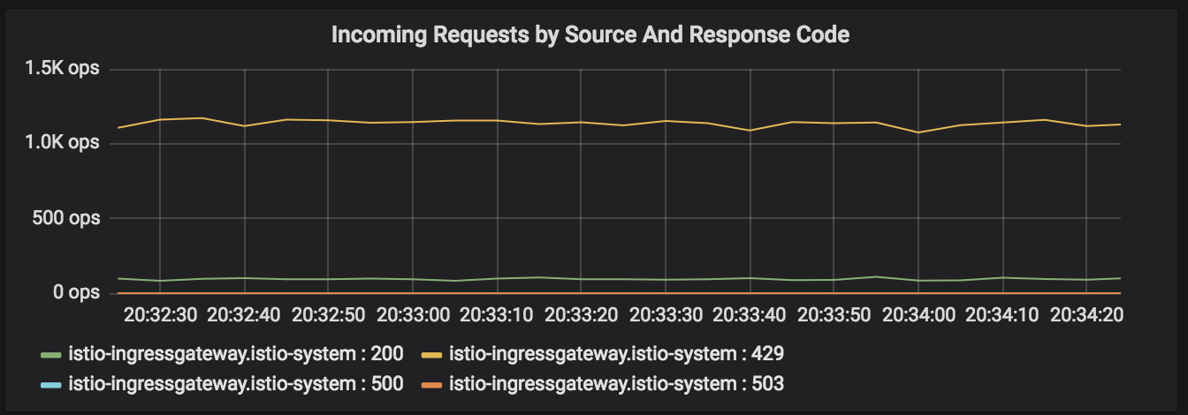

You can see large number of **429** (**Too Many Requests**) messages.

Switch the **Service** dropdown back to the **backend.production.svc.cluster.local**service and inspect the service graph.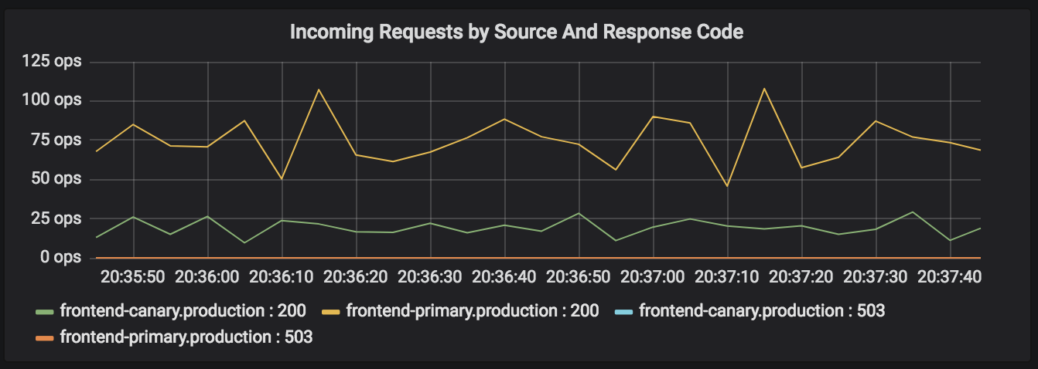

While the load is being generated, switch to the Chrome tab with the gke-centralingress gateway IP address and refresh the page a few times using the **CTRL-R** key combination. You often see this message.

RESOURCE\_EXHAUSTED:Quota is exhausted for: RequestCount

Learn more about [Rate Limiting](https://istio.io/docs/tasks/policy-enforcement/rate-limiting/) on the Istio website.

Before proceeding to the next step, delete the rate limit rule by running the following command.

kubectl delete -f ~/advanced-kubernetes-workshop/lb/rate-limit-frontend.yaml --context gke-central

Output (Do not copy)

Deleted config: quota-spec/istio-system/request-count

Deleted config: quota-spec-binding/istio-system/request-count

Deleted config: memquota/istio-system/handler

Deleted config: quota/istio-system/requestcount

Deleted config: rule/istio-system/quota

Stop the **hey** traffic generator prior to next section. In the **hey** Cloud Shell window, use the **CTRL-Z** key combination if the **hey** traffic generator is still running.

#### Circuit Breaking

Circuit breaking is an important pattern for creating resilient microservice applications. Circuit breaking allows you to write applications that limit the impact of failures, latency spikes, and other undesirable effects of network peculiarities.

In this task, you configure circuit breaking rules for the backend service and then test the configuration by intentionally "tripping" the circuit breaker.

Create a destination rule to apply circuit breaking settings when calling the backendservice. Run the following command.

kubectl apply -f ~/advanced-kubernetes-workshop/lb/circuit-breaker-backend.yml --context gke-central

Output (Do not copy)

Updated config destination-rule/production/backend to revision 286108

Inspect the trafficPolicy section of the new backend DestinationRule. Run the following command.

kubectl get destinationrule backend -n production --context gke-central -o yaml

Output excerpt (Do not copy)

...

spec

...

trafficPolicy:

connectionPool:

http:

http1MaxPendingRequests: 1

maxRequestsPerConnection: 1

tcp:

maxConnections: 1

loadBalancer:

simple: ROUND\_ROBIN

outlierDetection:

baseEjectionTime: 180.000s

consecutiveErrors: 1

interval: 1.000s

maxEje

graph

ctionPercent: 100

tls:

mode: ISTIO\_MUTUAL

In the DestinationRule settings, you specified **maxConnections: 1** and **http1MaxPendingRequests: 1**. These rules indicate that if you exceed more than one connection and request concurrently, you should see some failures when the istio-proxy opens the circuit for further requests and connections.

Run the **hey** test with **2** concurrent connections for **5** minutes. Run the following command.

export GKE\_ONE\_ISTIO\_GATEWAY=$(kubectl get svc istio-ingressgateway -n istio-system -o jsonpath="{.status.loadBalancer.ingress[0].ip}" --context gke-central)

hey -c 2 -z 5m http:*//$GKE\_ONE\_ISTIO\_GATEWAY*

After 5 mins, inspect the Grafana service for the frontend.production service.. You can see that almost all requests make it through as Istio allows for some leeway.

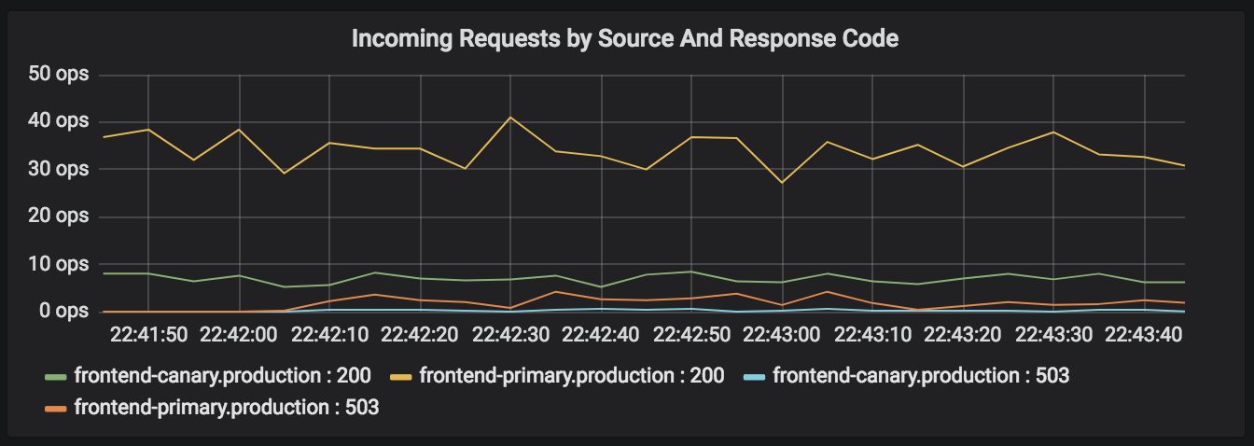

Let the **hey** traffic generator complete. Re-run the test with **3** concurrent connections. Run the following command.

hey -c 3 -z 5m http:*//$GKE\_ONE\_ISTIO\_GATEWAY*

After 5 mins, inspect the Grafana service graph for the frontend.productionservice..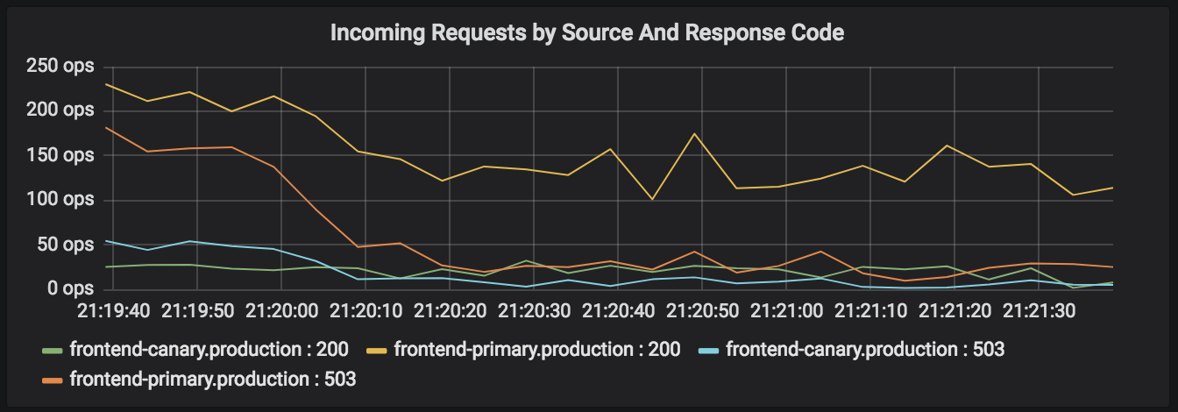

You now see a lot more **503** (**Service Unavailable**) messages. Query the istio-proxy stats from one of the frontend pods. You can log in to the istio-proxy of one of the frontend pods to see more details. Run the following command.

export FRONTEND\_POD=$(kubectl get pods -l app=frontend -n production --context gke-central | awk 'NR == 3 {print $1}')

kubectl exec -it $FRONTEND\_POD -n production --context gke-central -c istio-proxy -- sh -c 'curl localhost:15000/stats' | grep "||backend.production" | grep pending

Output (Do not copy)

cluster.outbound|80||backend.production.svc.cluster.local.upstream\_rq\_pending\_active: 0

cluster.outbound|80||backend.production.svc.cluster.local.upstream\_rq\_pending\_failure\_eject: 0

cluster.outbound|80||backend.production.svc.cluster.local.upstream\_rq\_pending\_overflow: 6674

cluster.outbound|80||backend.production.svc.cluster.local.upstream\_rq\_pending\_total: 14979

You see **6674** for the upstream\_rq\_pending\_overflow value which means 6674 calls so far have been flagged for circuit breaking.

Remove the circuit breaker prior to the next section. Run the following commands to delete the circuit breaker destination rule and reconfigure the original destinationrule for the backend service.

kubectl delete -f ~/advanced-kubernetes-workshop/lb/circuit-breaker-backend.yml --context gke-central

kubectl create -f ~/advanced-kubernetes-workshop/lb/backend-destination-rule.yml --context gke-central

Output (Do not copy)

Deleted config: destination-rule/production/backend

Created config destination-rule/production/backend at revision 122084

#### Securing the mesh

In addition to advanced routing and policy and quota management, another benefit Istio provides is end to end security between services running inside the service mesh. In this workshop, there are frontend and backend deployments talking to each other. In real world scenarios, there can be hundreds of services (with different versions) talking to each other. Security is a top priority in this situation.

You can install Istio with or without mutual TLS (mTLS) turned on mesh wide. For this workshop, the Istio implementations have mTLS turned on and thus by default all pod-to-pod communication is encrypted using certificates provided and managed by Citadel.

This workshop covers [Transport authentication](https://istio.io/docs/concepts/security/#authentication), also known as service-to-service authentication (for which Istio uses mTLS for service to service communication).

Inspect the default MeshPolicy which is a policy that configures mTLS. Run the following command.

kubectl get meshpolicy -n production --context gke-central -o yaml

Output excerpt (Do not copy)

...

spec:

peers:

- mtls: {}

The peers spec dictates that mTLS is turned on mesh wide.

Recall that the DestinationRule for both frontend and backend services also have TLS settings defined. Run the following command to inspect the DestinationRule for both services.

kubectl get destinationrule frontend -n production --context gke-central -o yaml

kubectl get destinationrule backend -n production --context gke-central -o yaml

Output excerpt for both services (Do not copy)

...

trafficPolicy:

loadBalancer:

simple: ROUND\_ROBIN

tls:

mode: ISTIO\_MUTUAL

Istio automatically installs necessary keys and certificates for mutual TLS authentication in all sidecar containers. Run command below to confirm key and certificate files exist under /etc/certs for one of the frontend pods.

export FRONTEND\_POD=$(kubectl get pods -l app=frontend -n production --context gke-central | awk 'NR == 3 {print $1}')

kubectl exec $FRONTEND\_POD -n production --context gke-central -c istio-proxy -- ls /etc/certs

Output (Do not copy)

cert-chain.pem

key.pem

root-cert.pem

cert-chain.pem is Envoy's cert that needs to be presented to the other side. key.pem is Envoy's private key paired with Envoy's cert in cert-chain.pem. root-cert.pem is the root cert to verify the peer's cert. In this example, we only have one Citadel in a cluster, so all Envoys have the same root-cert.pem.

Use the openssl tool to check if certificate is valid (current time should be in between Not Before and Not After). Run the following command.

kubectl exec $FRONTEND\_POD -n production --context gke-central -c istio-proxy -- cat /etc/certs/cert-chain.pem | openssl x509 -text -noout | grep Validity -A 2

Output (Do not copy)

Validity

Not Before: Sep 7 05:16:35 2018 GMT

Not After : Dec 6 05:16:35 2018 GMT

You can also check the identity of the client certificate. Run the following command.

kubectl exec $FRONTEND\_POD -n production --context gke-central -c istio-proxy -- cat /etc/certs/cert-chain.pem | openssl x509 -text -noout | grep 'Subject Alternative Name' -A 1

Output (Do not copy)

X509v3 Subject Alternative Name:

URI:spiffe://cluster.local/ns/production/sa/default

The default service account is utilized in the absence of any defined service account. Istio uses SPIFFE identity framework. Istio and SPIFFE share the same identity document: SVID (SPIFFE Verifiable Identity Document). For example, in Kubernetes, the X.509 certificate has the URI field in the format of "spiffe://<domain>/ns/<namespace>/sa/<serviceaccount>". This enables Istio services to establish and accept connections with other SPIFFE-compliant systems.

Even though the MeshPolicy seen earlier dictates that every service must use mutual TLS, you can disable mTLS on a per service basis.

Recall your Spinnaker pipeline from the previous lab.



The stage labeled **Run Backend tests on GKE Central** runs a Kubernetes job. Currently, with Istio, Kubernetes jobs do not function perfectly well with a sidecar container. Since the sidecar container has no visibility to when the job container finished successfully (or unsuccessfully for that matter), it continues to run. The job never finishes. You need the sidecar container due to mTLS since the istio-proxyis where the certificates are stored. In order to bypass this, you implemented an authentication policy to simply disable mTLS just for the backend service running in the staging namespace. Inspect the authentication policy for the backend service in the staging namespace.

kubectl get policy -n staging --context gke-central -o yaml

Output excerpt (Do not copy)

...

spec:

peers:

- mtls:

mode: PERMISSIVE

targets:

- name: backend

This configures the backend.staging service to accept both types of traffic: plain text and TLS. Thus, no request is dropped. This setting in combination with disabling the automatic sidecar injection via annotations allow you to complete the test job successfully.

Describe the job used to test the staging backend service by running the following command.

kubectl describe job -n staging --context gke-central

Output excerpt (Do not copy)

...

Annotations:

...

sidecar.istio.io/inject=false

Containers:

call-curl:

Image: gcr.io/spinnaker-marketplace/halyard:stable

Port: <none>

Command:

/bin/sh

Args:

-c

curl http://backend.staging/

The annotation sidecar.istio.io/inject=false disables automatic sidecar injection for this workload. The Args field displays the job which is a simple curl to the backend.staging service. Even though the backend.staging service has an istio-proxy sidecar with certificates, it can accept both mTLS and plain text requests.

### Global Load Balancing

Prior to this section, complete the spinnaker pipeline.

From the **Spinnaker GUI > PIPELINES** page. Hover over the orange rectangles for both pipelines and click **Continue**.

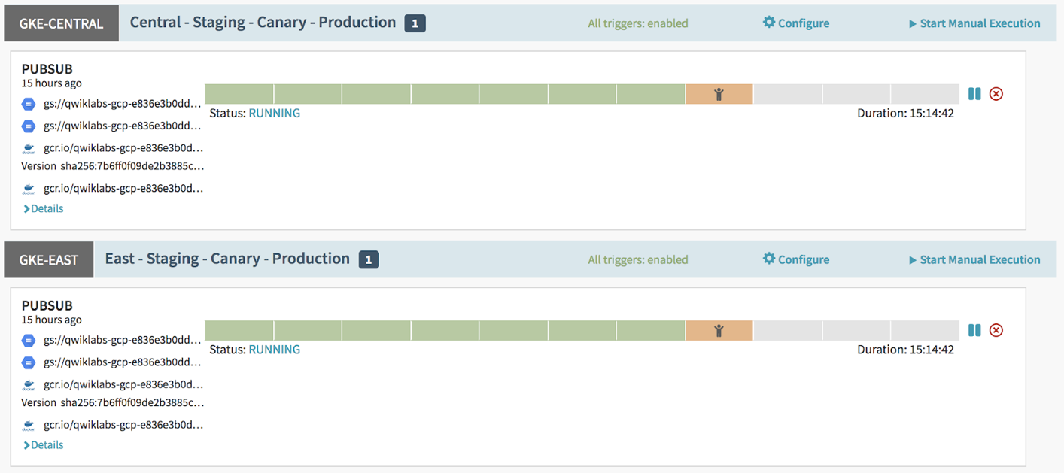

Ensure both pipelines complete successfully before proceeding.

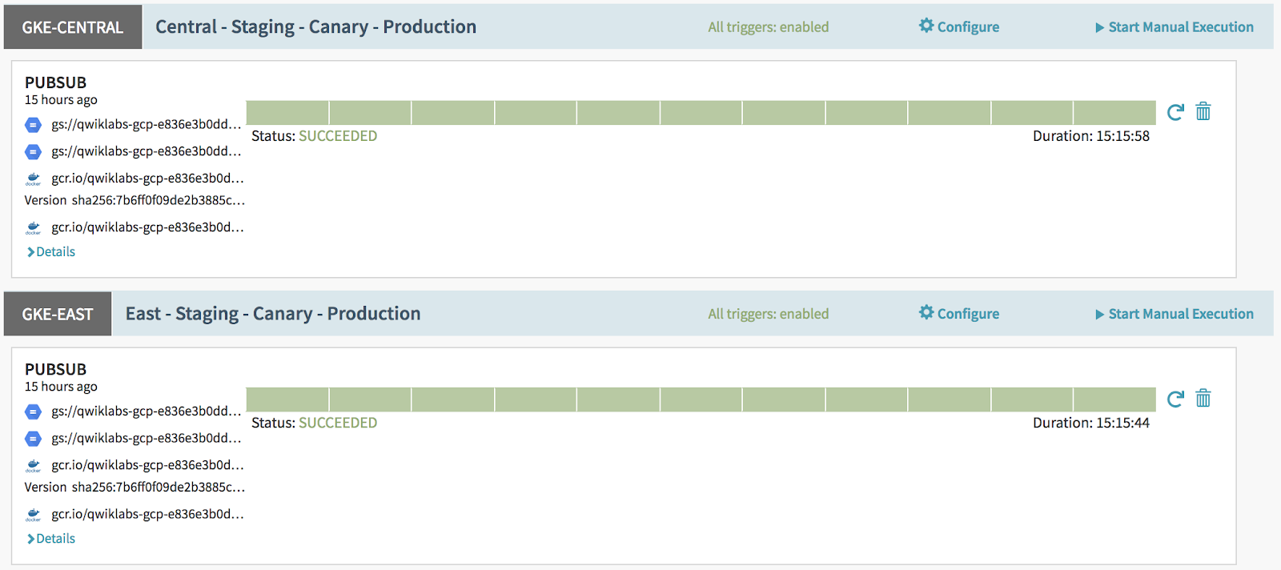

For this workshop, you use NGINX load balancer to direct traffic to the web application running in both gke-central and gke-west clusters. In production environments, you can use a third party provider for this service. [CloudFlare](https://www.cloudflare.com/" \t "_blank), [Akamai](https://www.akamai.com/" \t "_blank)or [backplane.io](https://www.backplane.io/) all provide this functionality.

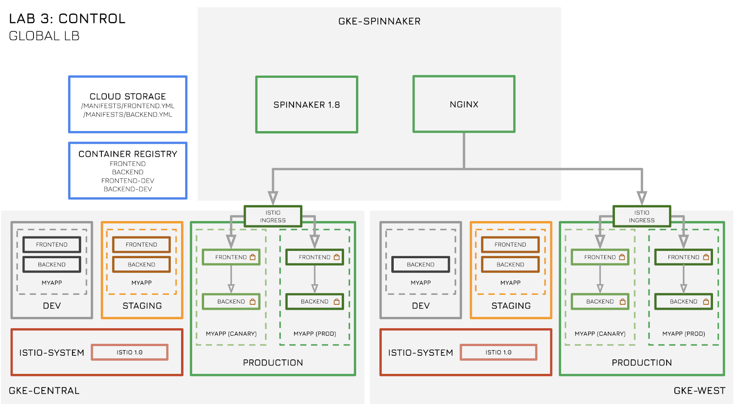Store the Ingress IP addresses for the two clusters in variables.

export GKE\_ONE\_ISTIO\_GATEWAY=$(kubectl get svc istio-ingressgateway -n istio-system -o jsonpath="{.status.loadBalancer.ingress[0].ip}" --context gke-central)

export GKE\_TWO\_ISTIO\_GATEWAY=$(kubectl get svc istio-ingressgateway -n istio-system -o jsonpath="{.status.loadBalancer.ingress[0].ip}" --context gke-west)

#### Creating NGINX ConfigMap

You can use gke-spinnaker for global load balancing. Create an NGINX ConfigMap in gke-spinnaker. This ConfigMap provides the load-balancer.conf file to the NGINX deployment used to globally load balance traffic to both gke-central and gke-west clusters. The ConfigMap template file uses placeholder values for backend IPs (i.e. cluster Ingress IPs) which need to be replaced before applying it.

kubectx gke-spinnaker

cd ~/advanced-kubernetes-workshop/lb

sed -e s/CLUSTER1\_INGRESS\_IP/$GKE\_ONE\_ISTIO\_GATEWAY\ weight=1/g -e s/CLUSTER2\_INGRESS\_IP/$GKE\_TWO\_ISTIO\_GATEWAY\ weight=1/g glb-configmap-var.yaml > glb-configmap.yaml

Confirm that the Ingress IP addresses are in the output file.

cat glb-configmap.yaml

Output excerpt (Do not copy)

...

load-balancer.conf: |

upstream example.com {

server 35.188.96.218 weight=1;

server 35.231.81.175 weight=1;

...

Apply the configmap.

kubectl apply -f glb-configmap.yaml

#### Creating NGINX Deployment and Service

Create the NGINX deployment and service

kubectl apply -f nginx-dep.yaml

kubectl apply -f nginx-svc.yaml

Ensure that the global-lb-nginx Service has a public IP address. You can run the following commands a few times or watch it using the -w option in the command line.

kubectl get service global-lb-nginx

#### Accessing NGINX load balancer frontend

Once you have the public IP address, store it in a variable.

export GLB\_IP=$(kubectl get service global-lb-nginx -o jsonpath='{.status.loadBalancer.ingress[0].ip}')

Do a loop-curl to the NGINX frontend IP address to ensure traffic is being sent to both gke-central and gke-west clusters.

for i in `seq 1 20`; do curl -s $GLB\_IP | grep gke | sed -e 's/<p>/ /g' -e 's/<\/p>/ /g'; done

Output (Do not copy)

gke-west

gke-central

gke-west

gke-central

gke-west

gke-central

gke-west

gke-central

gke-west

gke-central

gke-west

gke-central

gke-west

gke-central

gke-west

gke-central

gke-west

gke-central

gke-west

gke-central

Traffic to the two clusters is being split 50/50. This ratio can be controlled by the weight field in the ConfigMap generated earlier. Recall that you set the weightfields for both backends (or Istio Ingress gateway IPs) in the NGINX ConfigMap to 1.

#### Controlling global traffic to both clusters using NGINX

Adjust the weight fields in the ConfigMap. Change the weight for gke-west (or cluster-2) to 4. Set the weight for gke-central (or cluster-1) to 1 (same as before). Apply the new configmap and recreate the deployment for the new ConfigMap.

sed -e s/CLUSTER1\_INGRESS\_IP/$GKE\_ONE\_ISTIO\_GATEWAY\ weight=1/g -e s/CLUSTER2\_INGRESS\_IP/$GKE\_TWO\_ISTIO\_GATEWAY\ weight=4/g glb-configmap-var.yaml > glb-configmap-2.yaml

kubectl delete -f glb-configmap.yaml

kubectl delete -f nginx-dep.yaml

kubectl apply -f glb-configmap-2.yaml

kubectl apply -f nginx-dep.yaml

Review the configmap by running the following command.

kubectl get configmap nginx --context gke-spinnaker -o yaml | head -7

Output (Do not copy)

apiVersion: v1

data:

load-balancer.conf: |

upstream example.com {

server 35.225.163.174 weight=1;

server 35.230.67.55 weight=4;

}

Notice the weight ratio for the two clusters. gke-central cluster has a weight of **1** and gke-west cluster has a weight of **4**. This means **4** times more traffic is sent to the gke-west cluster compared to gke-central cluster.

Wait a few moments for the NGINX service to come up. Do a for loop curl on the GLB\_IP and you can see more traffic going to gke-west due to higher weight (4 versus 1).

for i in `seq 1 20`; do curl -s $GLB\_IP | grep gke | sed -e 's/<p>/ /g' -e 's/<\/p>/ /g'; done

Output (Do not copy)

gke-west

gke-west

gke-central

gke-west

gke-west

gke-west

gke-west

gke-central

gke-west

gke-west

gke-west

gke-west

gke-central

gke-west

gke-west

gke-west

gke-west

gke-central

gke-west

gke-west

## END OF LAB 3 - Please STOP and wait for instructions before proceeding!

## Lab 4: Monitor (45 mins)

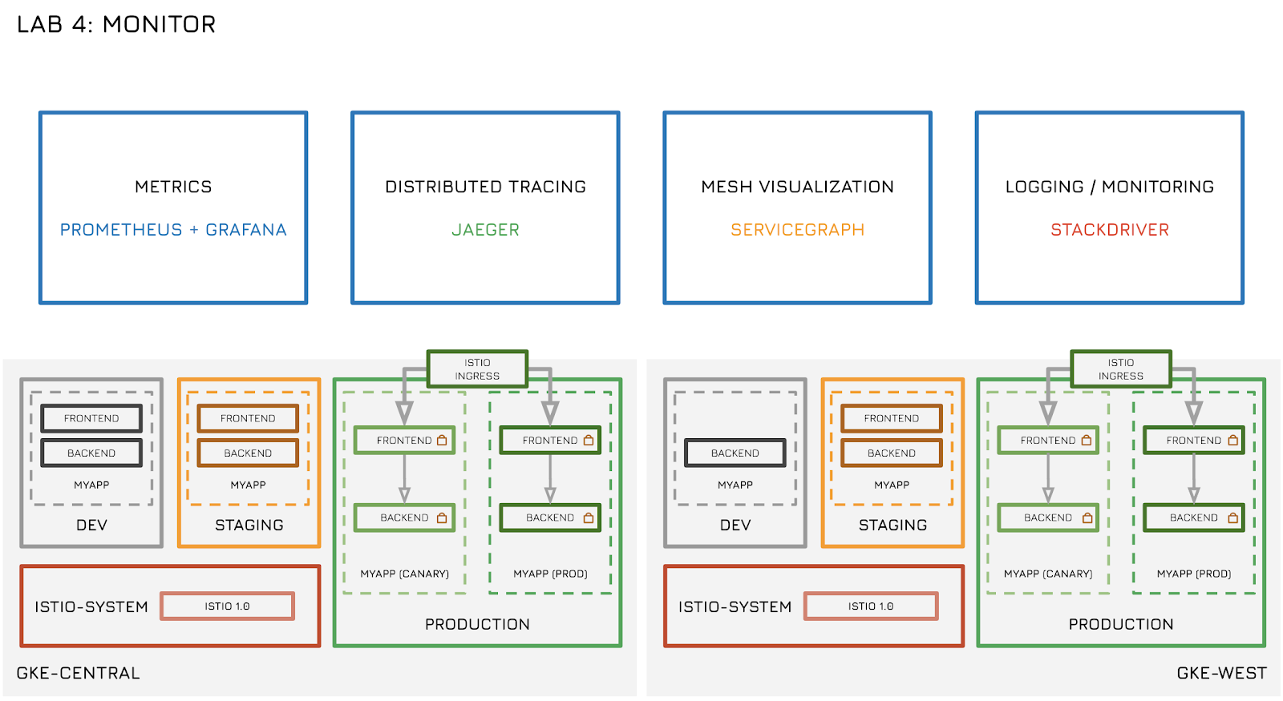

In this lab, you:

* Use Istio addons to monitoring and troubleshooting.
* Use [Prometheus](https://prometheus.io/) and [Grafana](https://grafana.com/) for metrics and visualization.
* Use [Jaeger](https://www.jaegertracing.io/) for distributed tracing.
* Use [Google Stackdriver](https://cloud.google.com/stackdriver/) for monitoring multiple Kubernetes Engine clusters and logging.
* Use [Servicegraph](https://istio.io/docs/tasks/telemetry/servicegraph/" \t "_blank) for service mesh visualization.

### Collecting metrics with Prometheus and Grafana

Mixer comes with a built-in Prometheus adapter that exposes an endpoint serving generated metric values. The Prometheus add-on is a Prometheus server that comes preconfigured to scrape Mixer endpoints to collect the exposed metrics. It provides a mechanism for persistent storage and querying of Istio metrics.

The configured Prometheus add-on scrapes three endpoints:

* istio-mesh (istio-mixer.istio-system:42422): all Mixer-generated mesh metrics.
* mixer (istio-mixer.istio-system:9093): all Mixer-specific metrics. Used to monitor Mixer itself.
* envoy (istio-mixer.istio-system:9102): raw stats generated by Envoy (and translated from Statsd to Prometheus).

Ensure that Prometheus port 9090 (and 9091 for gke-west cluster) is exposed using the workshop\_connect script. If in doubt, re-run the script by running the following command.

workshop\_connect

Click **Web Preview** in Cloud Shell (top bar, right hand side) and click **Change port**.



Change the port to **9090** and click **Change and Preview**. This opens a new tab in Chrome for Prometheus. Execute a Prometheus query. In the "Expression" input box at the top of the web page, enter the text: istio\_requests\_total. Then, click the **Execute** button.

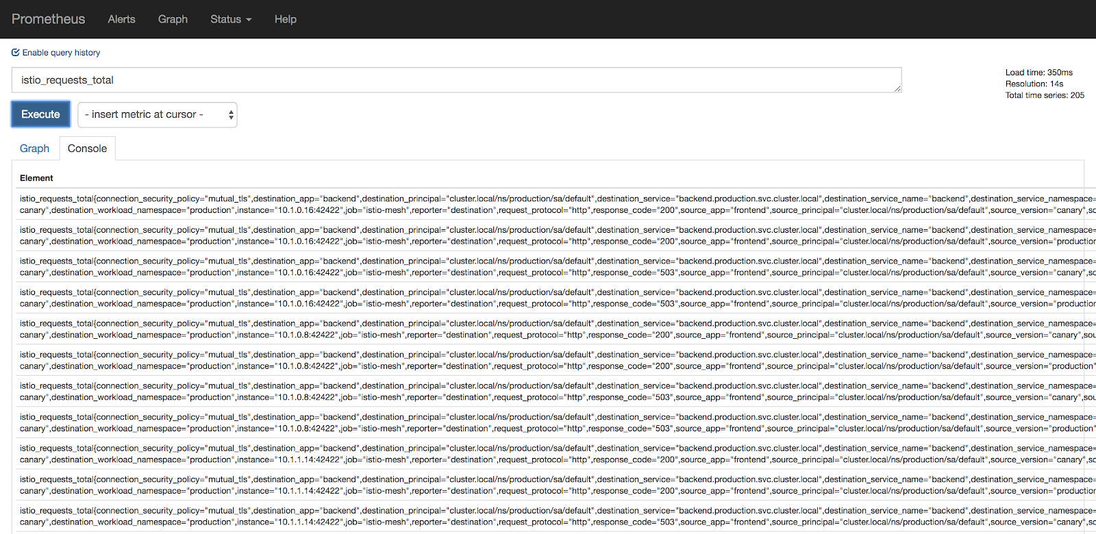

Try a few other queries and inspect the values. Generate some traffic using hey to get interesting metrics.

Total count of all requests to the backend service.

istio\_requests\_total{destination\_service="backend.production.svc.cluster.local"}

Total count of all requests to canary version of the frontend service.

istio\_requests\_total{destination\_service="frontend.production.svc.cluster.local", destination\_version="canary"}

Rate of requests over the past **5** minutes to all instances of the frontend service.

rate(istio\_requests\_total{destination\_service=~"frontend.\*", response\_code="200"}[5m])

Generate some traffic using **hey**. Run the following command.

export GKE\_ONE\_ISTIO\_GATEWAY=$(kubectl get svc istio-ingressgateway -n istio-system -o jsonpath="{.status.loadBalancer.ingress[0].ip}" --context gke-central)

hey -z 10m http:*//$GKE\_ONE\_ISTIO\_GATEWAY*

Click on the Graph tab (under the Execute button). Change the time granularity to **1m**by clicking the minus button. Check the stacked checkbox. Hovering over the graph you get additional metrics per pod.

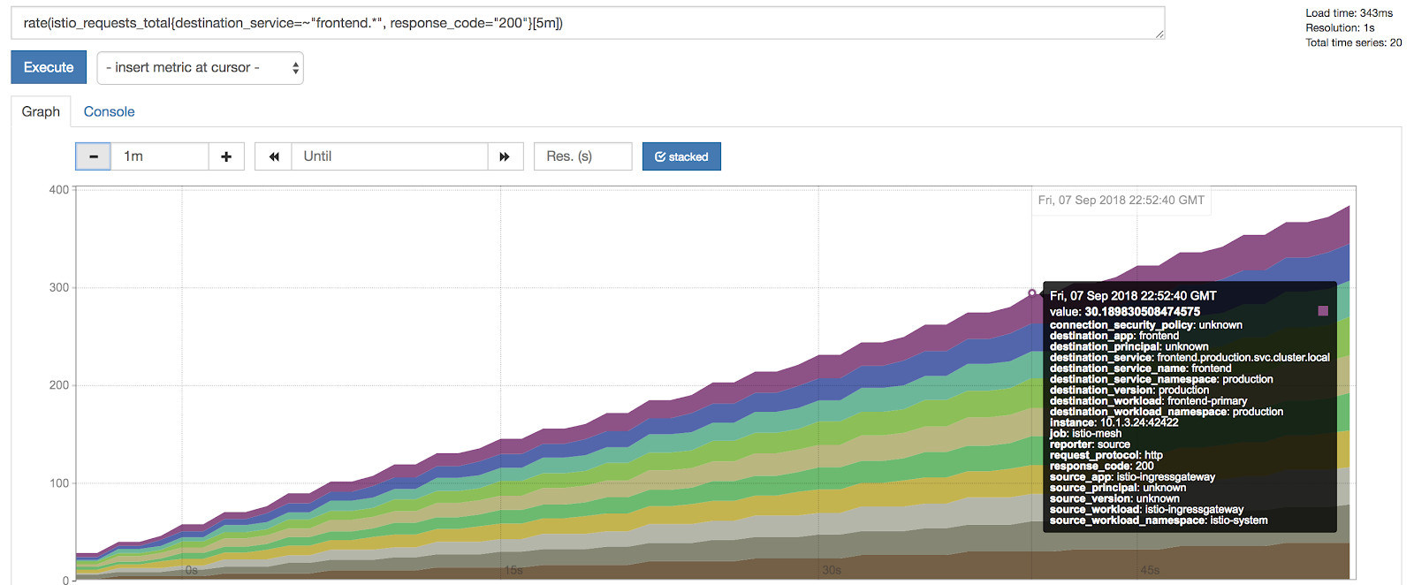

Most of the time, you use Grafana to visualize Prometheus metrics. Open Grafana Chrome tab (if its not already open).

Click **Web Preview** in Cloud Shell (top bar, right hand side) and click **Change port**.



Change the port to **3000** and click **Change and Preview**. This opens a new tab in Chrome for Grafana. Click on **Home** at the top and then **Istio Mesh Dashboard**.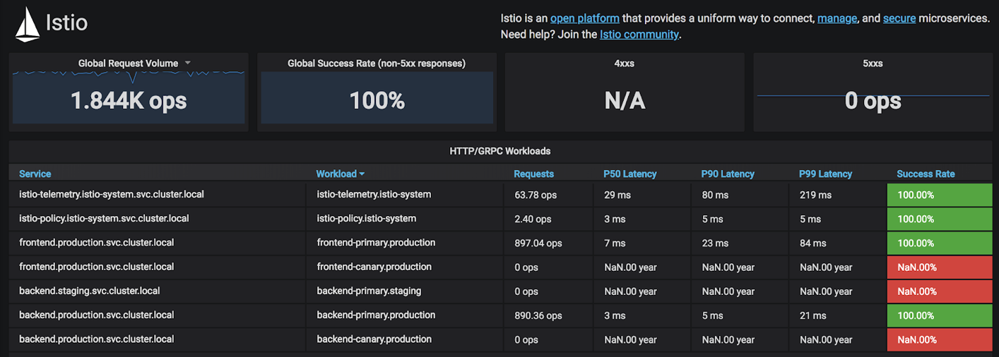

This table shows you all the services currently running on the gke-central cluster, global request volume and success rate.

Click on the **frontend.production.svc.cluster.local** service, which takes you to the **Istio Service Dashboard**. This is the same dashboard used in Lab 3. Hovering over a single chart and pushing **V** makes it full screen.

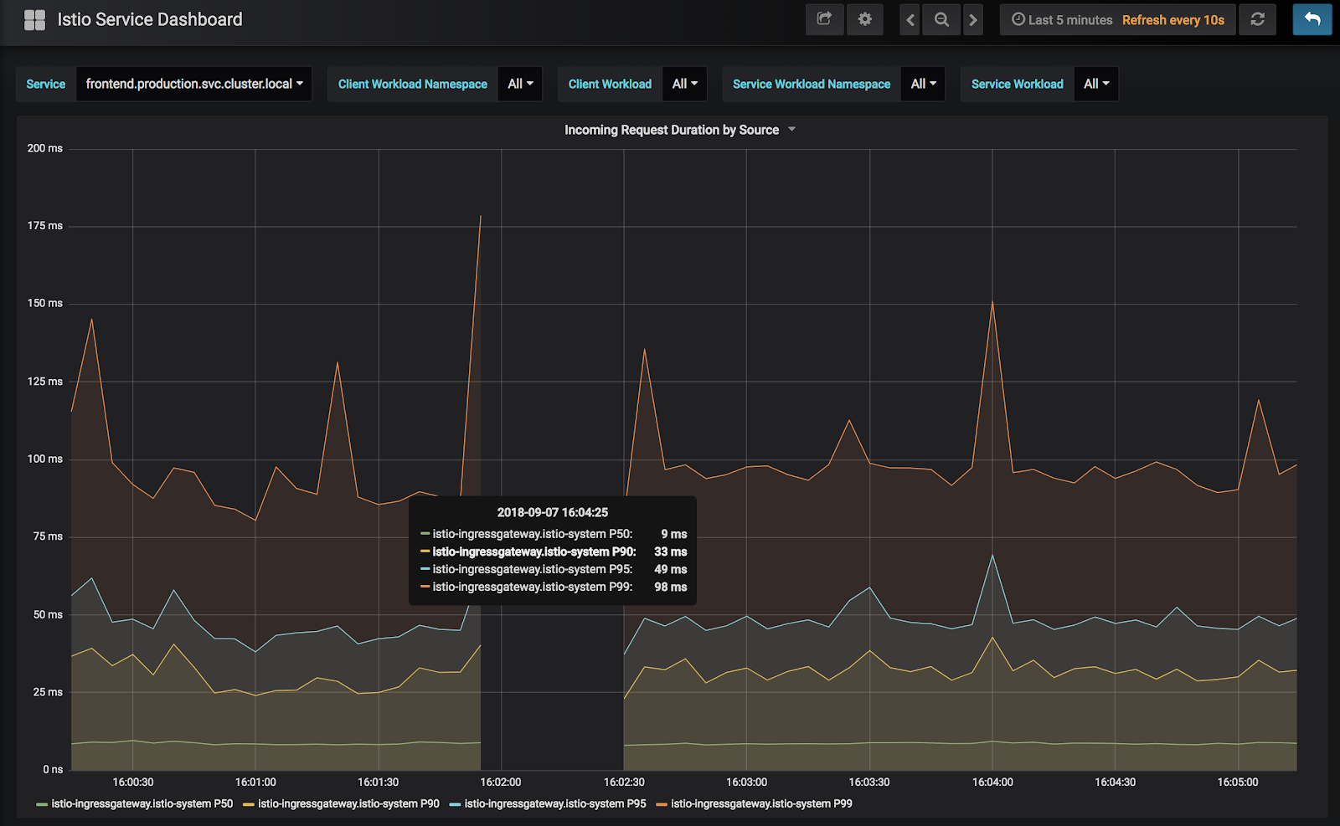

Use **ESC** key to go back.

**Note**: You may notice no traffic is being sent to either the frontend or the backend canary. Recall that you completed the Spinnaker pipeline which after promoting the current canary to production, deletes the canaries. This is why all traffic is going to the new production/primary frontend and backend services.

Click the **Incoming Request by Source and Response Code** > **More** and **Panel JSON**.

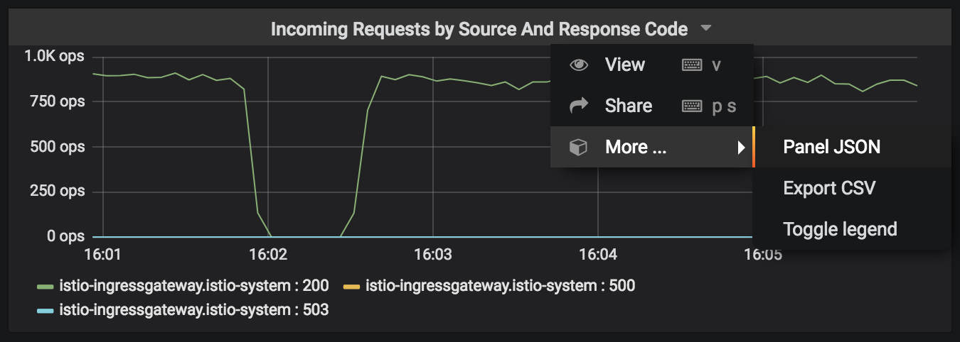

In the JSON Panel, scroll down to the targets object, which has information regarding the Prometheus metric being used.

At the top of the Istio Service Dashboard, from the **Service** dropdown, you can select all services running on the cluster and inspect metrics for a particular service.

Click the **Istio Service Dashboard** at the top and inspect all the other built-in dashboards.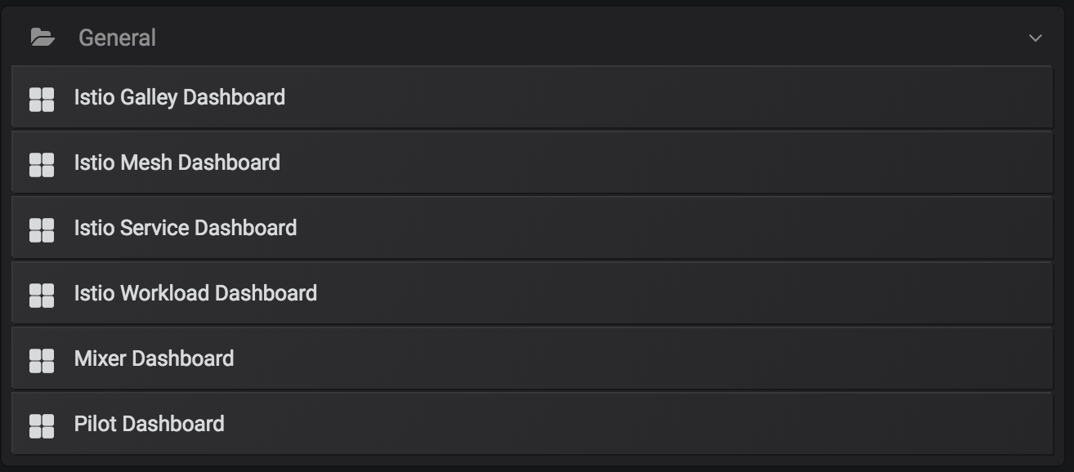

Click on the **Settings** icon in the left hand side column and then select **Data Sources**.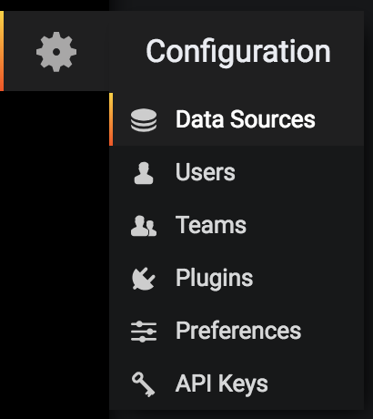

Click on the **Prometheus** data source and inspect the settings. Grafana is accessing Prometheus on port 9090.

### Troubleshooting via distributed tracing with Jaeger

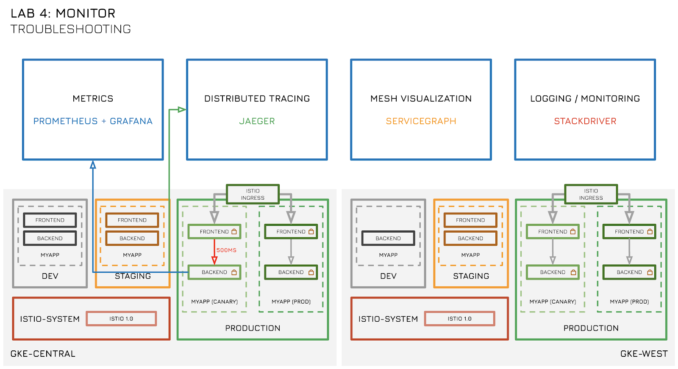

Click **Web Preview** in Cloud Shell (top bar, right hand side) and click **Change port**.



Change the port to **16686** and click **Change and Preview**. This opens a new tab in Chrome for Jaeger.

In the **Service** dropdown, select backend and click **Find Traces** at the bottom.

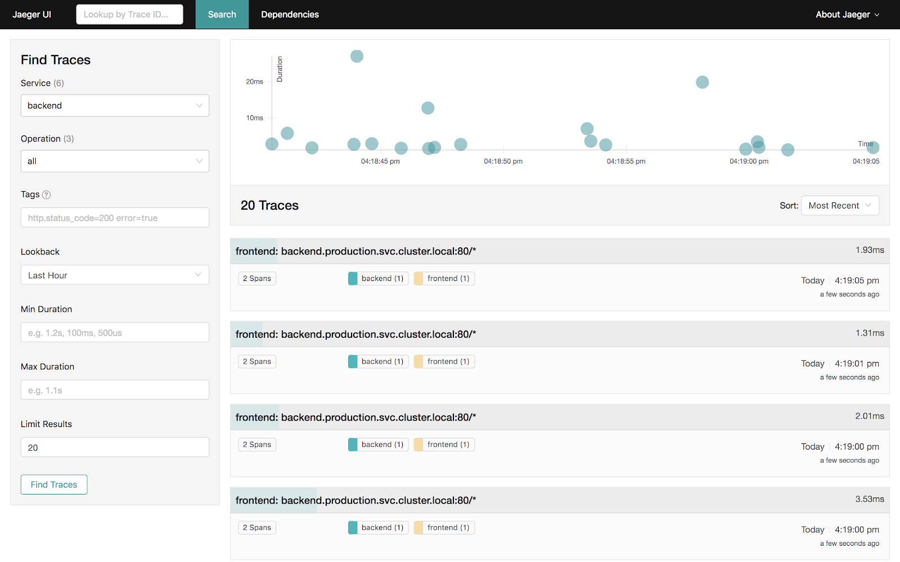

Select one of the traces and click individual operations to open more details.

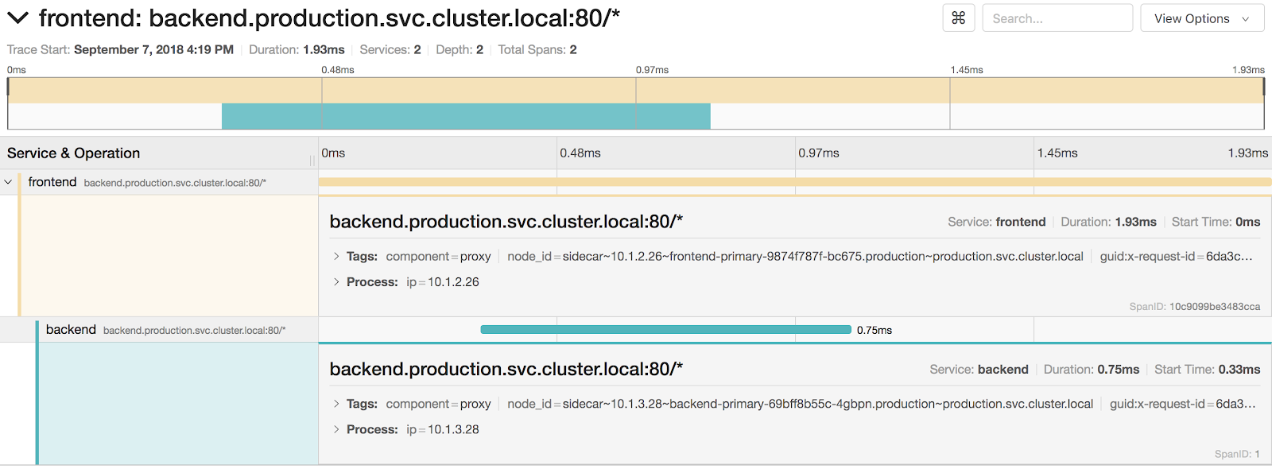

In this case, you see two services (frontend and backend) and the amount of time each operation takes. In the example above, the total time of the trace is **1.93ms**. The backend operation takes **0.75ms**.

Lets inject an artificial delay to the backend service to simulate faulty code. Prior to this, ensure no traffic is being sent to the application.

Inspect the main.go file for the backend service. Don't worry if you don't speak Go. Run the following command.

cat ~/advanced-kubernetes-workshop/services/backend/main.go

Output excerpt (Do not copy)

func index(w http.ResponseWriter, r \*http.Request) {

// duration := time.Duration(500)\*time.Millisecond

// time.Sleep(duration)

fmt.Printf("Handling %+v\n", r);

host, err := os.Hostname()

if err != nil {

http.Error(w, fmt.Sprintf("Error retrieving hostname: %v", err), 500)

return

}

msg := fmt.Sprintf("Host: %s\nSuccessful requests: %d", host, count)

count += 1

io.WriteString(w, msg)

}

The backend service consists of a function named index. The index function prints the pod's hostname and number of successful requests, which is displayed as messages on the frontend webpage. Inspect the first two lines of the function. They are currently commented out. These two lines of code inject a **500ms** delay when the function is called. Uncomment these lines by running the following commands.

sed -i -e 's|//||g' ~/advanced-kubernetes-workshop/services/backend/main.go

Build the app using the following command.

cd ~/advanced-kubernetes-workshop/services/backend/

./build.sh

Open the Spinnaker GUI. Click **Web Preview** in Cloud Shell (top bar, right hand side) and click **Change port**.



Change the port to **8080** and click **Change and Preview**. This opens a new tab in Chrome for Spinnaker.

Navigate to the **PIPELINES**page. You see the pipelines triggered. Click through the first manual judgement stage. Wait at the second manual judgement stage.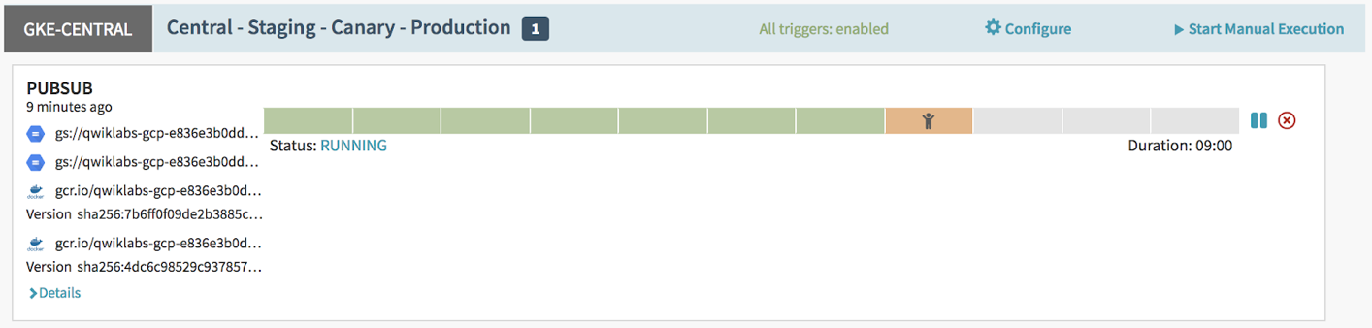

Generate some traffic using **hey**. Run the following command.

export GKE\_ONE\_ISTIO\_GATEWAY=$(kubectl get svc istio-ingressgateway -n istio-system -o jsonpath="{.status.loadBalancer.ingress[0].ip}" --context gke-central)

hey -z 10m http:*//$GKE\_ONE\_ISTIO\_GATEWAY*

Inspect the Grafana **Istio Service Dashboard** for the backend service. Look at the **Client and Server Request Duration** charts. Notice the P90 and P99 durations have considerably increased to above **500ms**. This is due to the delay injected in the previous step.

**Note:** Only the canary backend release is exhibiting the additional 500ms delay while the production (primary) backend is serving traffic without the additional delay.

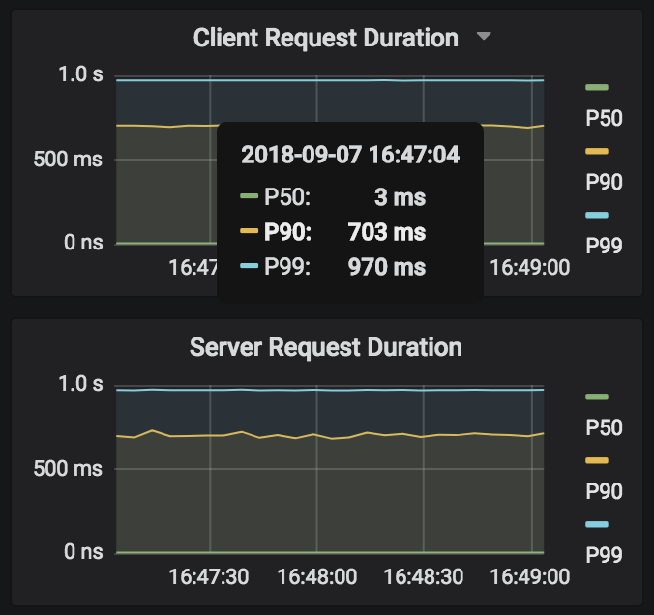

In the **Jaeger UI** tab home page, select the backend service and click on **Find Traces**at the bottom. Note the dots over 500ms.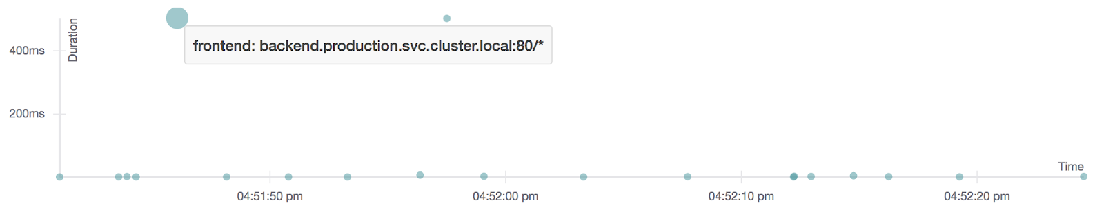

Click on one of these dots to open the details of this trace.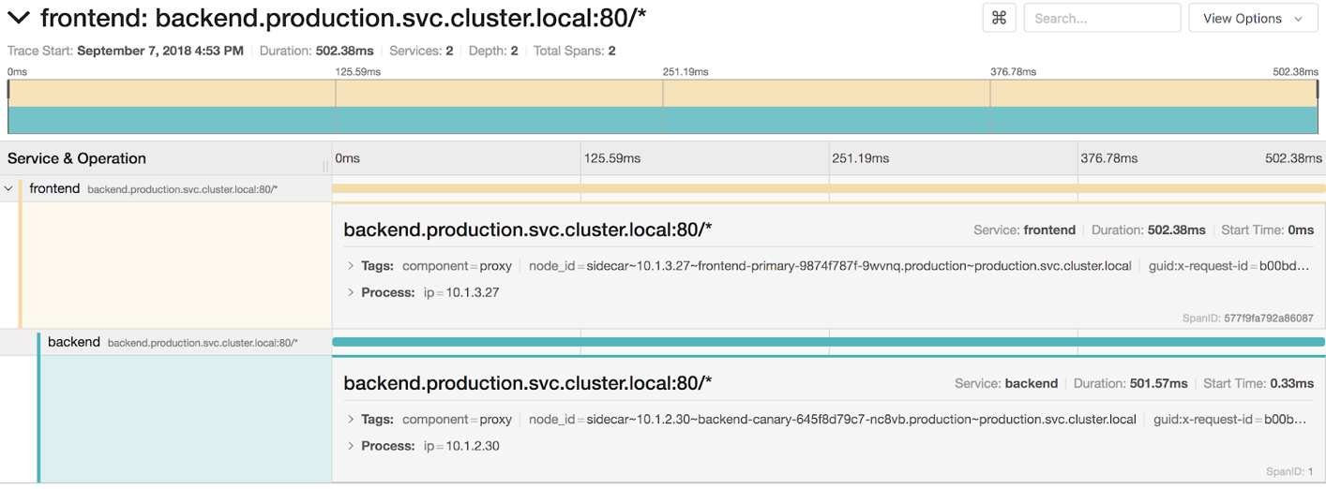

Note the start time on the backend service. In this case, the backend service start time is **0.33ms**, with a duration of **501.57ms**. This shows that the issue is with the backend service. You can also see the pod hostname in node\_id as well as the IP address. In this case, the pod hostname is backend-canary-645f8d79c7 with IP address of 10.1.2.30.

In the Spinnaker GUI, click on the cancel button to the right of the pipeline.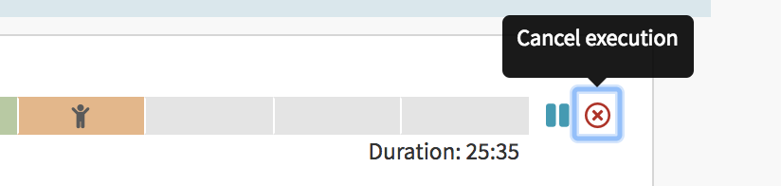

Optionally make a note of why you are canceling the pipeline.

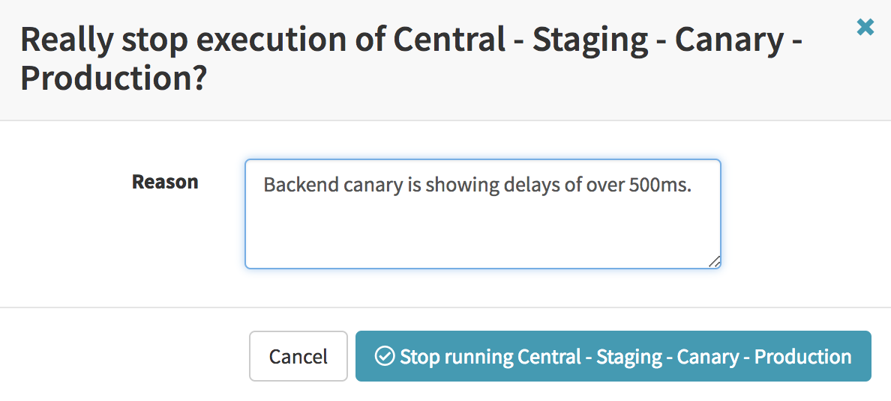

Note that canceling a Spinnaker pipeline does not revert back any changes. It simply ceases the pipeline at the current step. Anything deployed up to this point will remain. You may create another pipeline to delete the canaries that can be triggered automatically upon cancellation of another pipeline.

### Logging and Monitoring with Google Stackdriver

Google Stackdriver allows collection of Kubernetes Engine cluster metrics. The Kubernetes Engine clusters installed as part of this workshop already have this feature enabled. To verify, check the resources in the kube-system namespaces for each cluster and ensure that appropriate resources are installed. Run the following command.

kubectl get pods -n kube-system --context gke-central

kubectl get pods -n kube-system --context gke-west

kubectl get pods -n kube-system --context gke-spinnaker

Output excerpt (Do not copy)

...

NAME READY STATUS RESTARTS AGE

fluentd-gcp-scaler-7c5db745fc-ww7f7 1/1 Running 0 1h

...

heapster-v1.5.3-779d86c765-292qr 3/3 Running 0 1h

...

metadata-agent-47ffj 1/1 Running 11 1h

Ensure you have these resources running in each cluster.

* fluentd-gcp-...: the Stackdriver Logging agent.
* heapster-...: the Monitoring agent.
* metadata-... : the Stackdriver Metadata agent.

In the Cloud Console web GUI search bar, search for "monitoring". Click Monitoring.

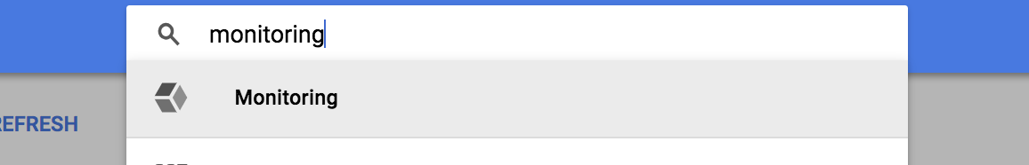

Create an account.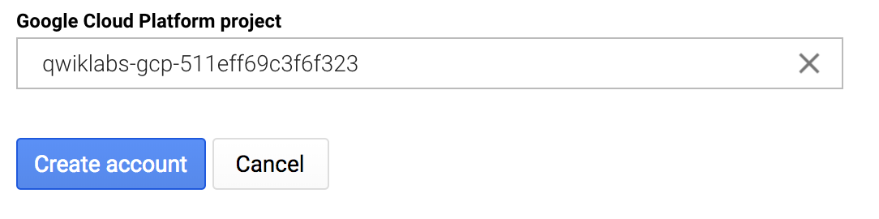

Click **Continue** on the next screen and **Skip AWS Setup** on the following screen. Click **Continue** again on the next screen. Select **No Reports** radio button on the next screen and click **Continue**. Wait a few moments for account creation to be completed successfully.

Click **Launch Monitoring**.

Click on **Resources** > **Kubernetes (BETA)** link.

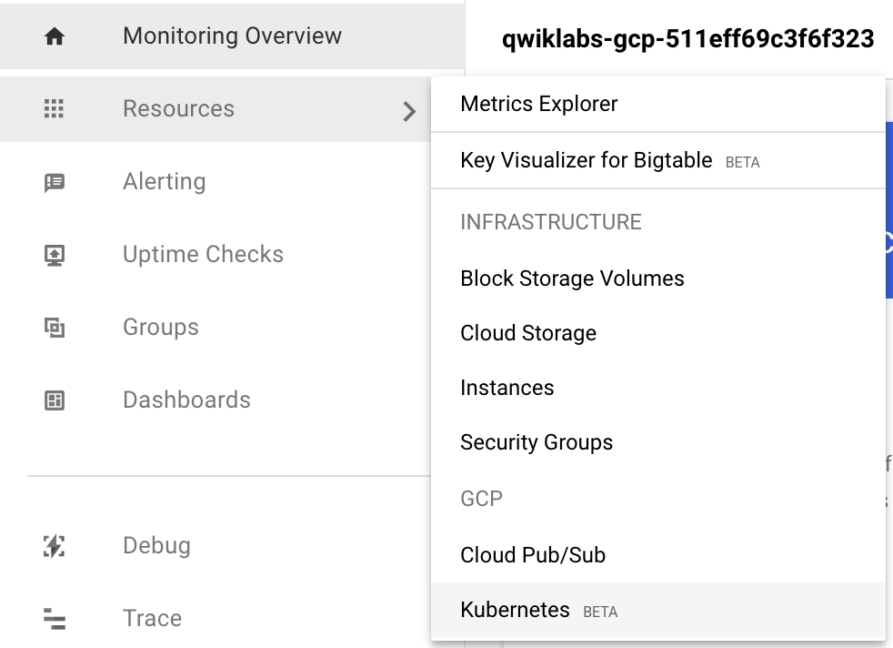

**Note**: If the Kubernetes (BETA) link does not show up right away. Wait a few moments and refresh the Monitoring page.

You can see the three Kubernetes Engine clusters.

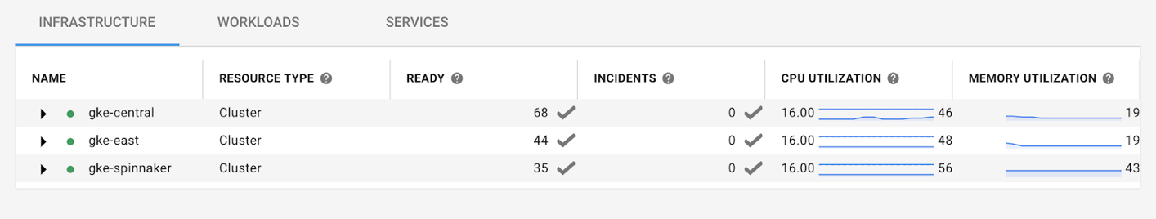

The main table consists of three tabs.

* Infrastructure
* Workloads
* Services

Navigate through the three tabs by opening up the clusters and looking through various metrics presented as part of the Kubernetes logging and monitoring agent.

Learn more about [observing your Kubernetes clusters](https://cloud.google.com/monitoring/kubernetes-engine/observing) via Stackdriver.

### Service Mesh Visualization with Servicegraph

Click **Web Preview** in Cloud Shell (top bar, right hand side) and click **Change port**.



Change the port to **8088** and click **Change and Preview**. This opens a new tab in Chrome for Servicegraph. You see a 404 page not found message.

Change the URL to look like the following. Add /force/forcegraph.html to the end of the URL.

https://8088-dot-12345678-dot-devshell.appspot.com/force/forcegraph.html

You can now see the servicegraph of your services.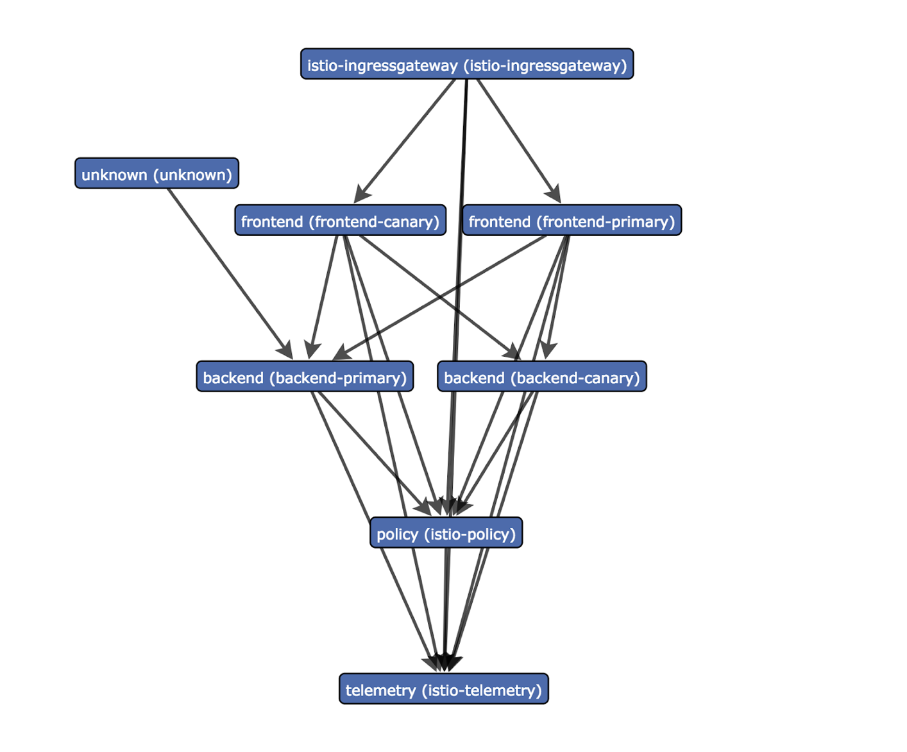

Generate some traffic and click on individual services to see more details.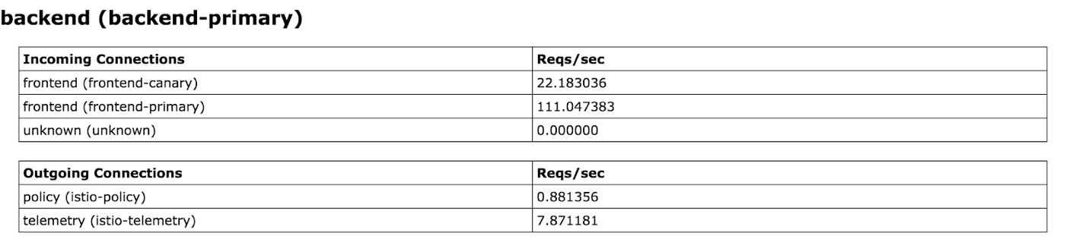

Change the URL to look as follows. Replace /force/foregraph.html with /dotviz.

https://8088-dot-12345678-dot-devshell.appspot.com/dotviz

Inspect the dotviz graph.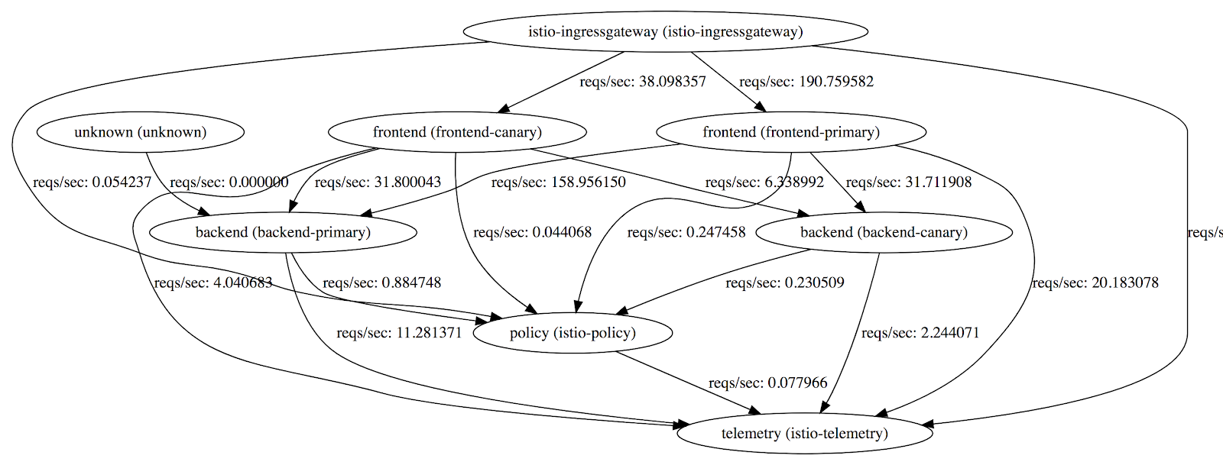

Other URL suffixes to try are.

* /dotgraph provides a DOT serialization.
* /d3graph provides a JSON serialization for D3 visualization.
* /graph provides a generic JSON serialization.

Congratulations on completing the Advanced Kubernetes Workshop by Google Cloud Platform. We hope you enjoyed your experience.

Your feedback is extremely important in making this a better workshop in the future. Please take a few minutes and let us know your thoughts.